Module 2

ASia pacific College

User Manual

SM Foundation Tracking System

August 28, 2015

# System Configurations

# Operations

* Front-end
  + 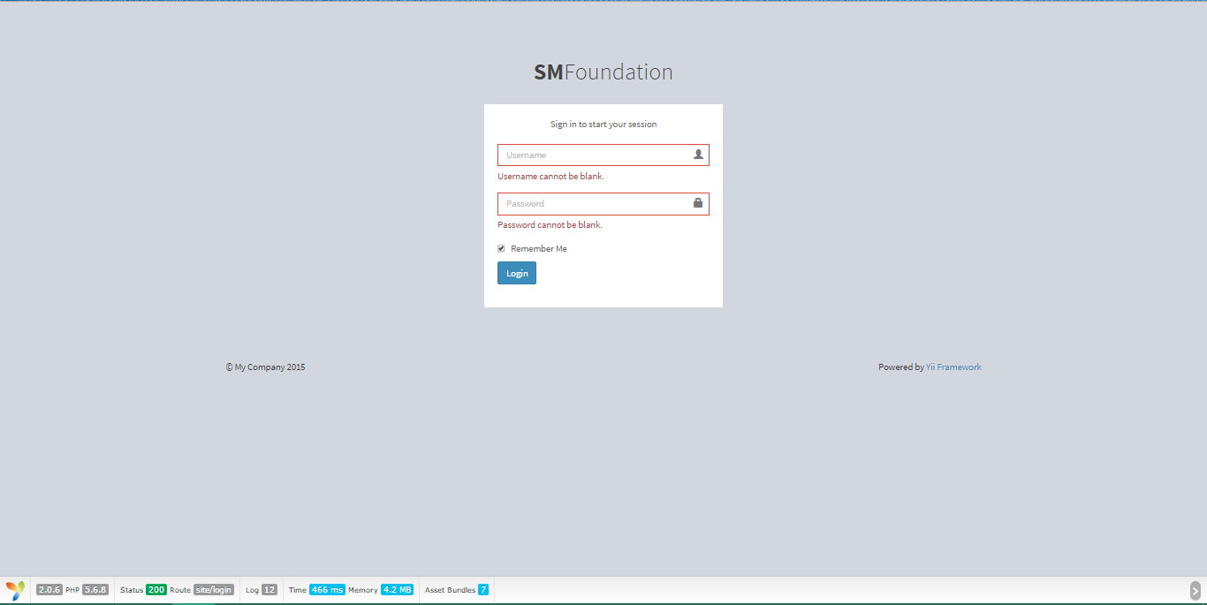Login

1. Enter Username and Password (credentials)
2. Optional: Tick Remember Me for autofill next login
3. Press Login
   * view profile (scholar)

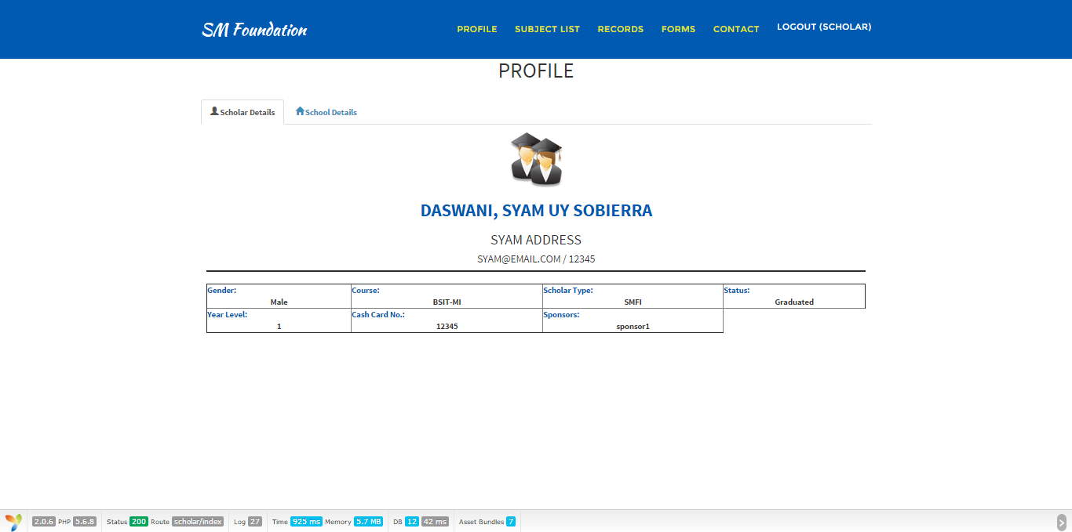

1. Go to Profile
2. Click Scholar Details
   * 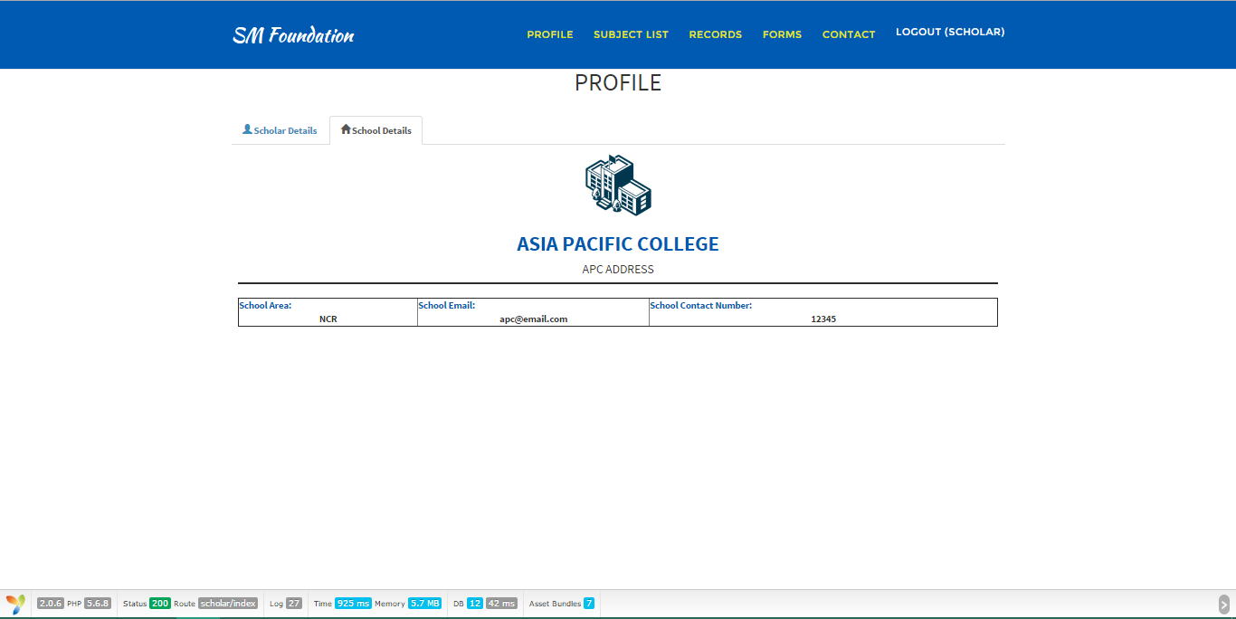View profile (school)
3. Go to Profile
4. Click School Details
   * 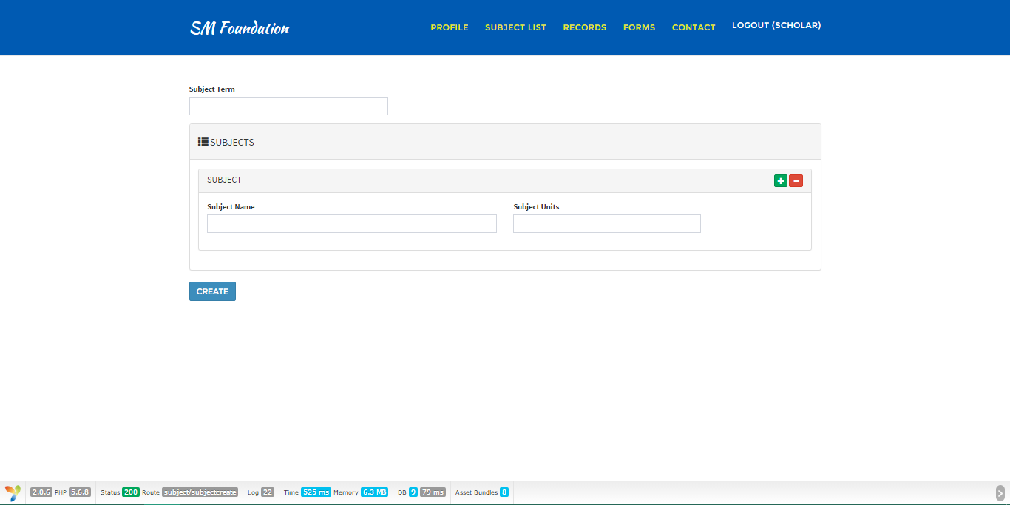View and create subjects
5. Go to subject list for viewing
6. If creating a subject: Fill out required information
   1. Press Create
   * 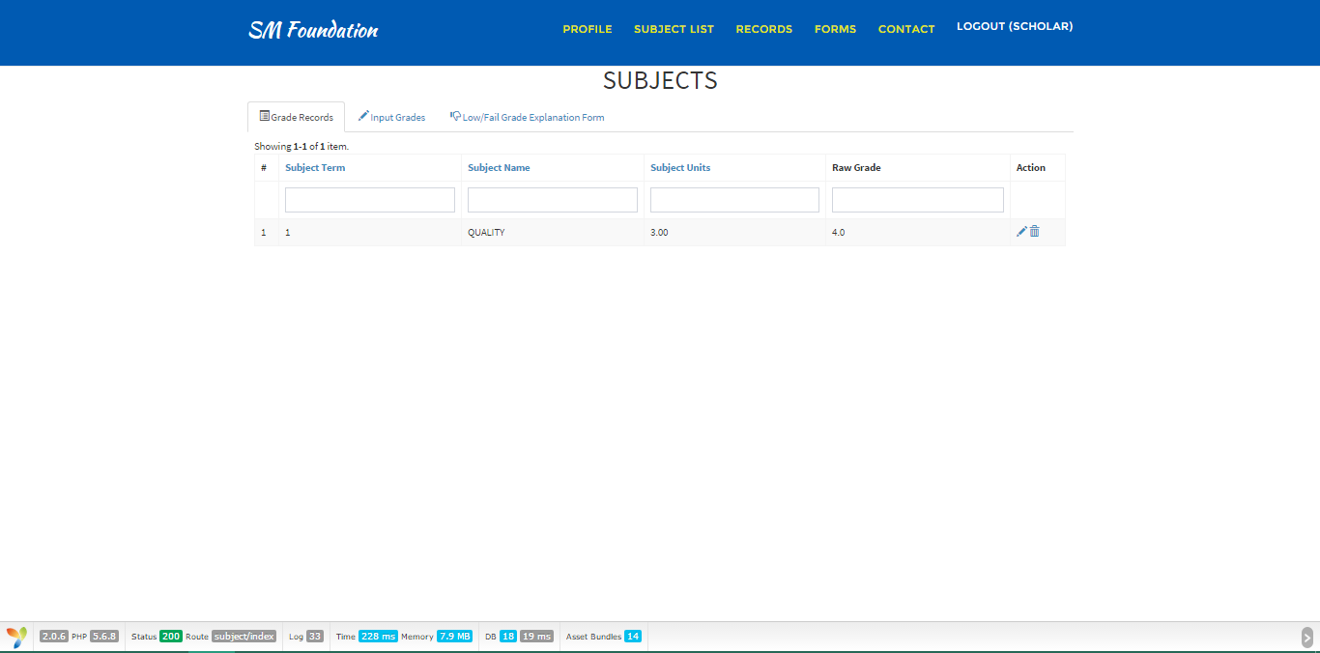view grades
   1. Go to Records > Grades
   2. Click Grade Records tab
   * 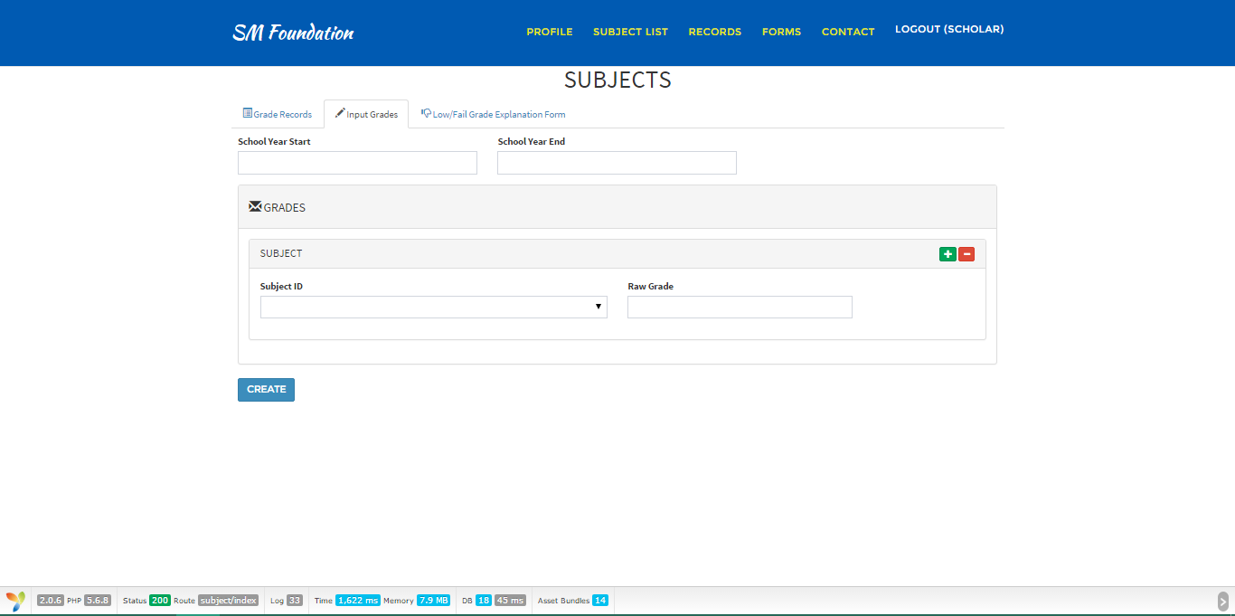create grades
   1. Go to Records > Grades
   2. Switch to Input Grades tab
   3. Fill out required information
   4. Click create
   * 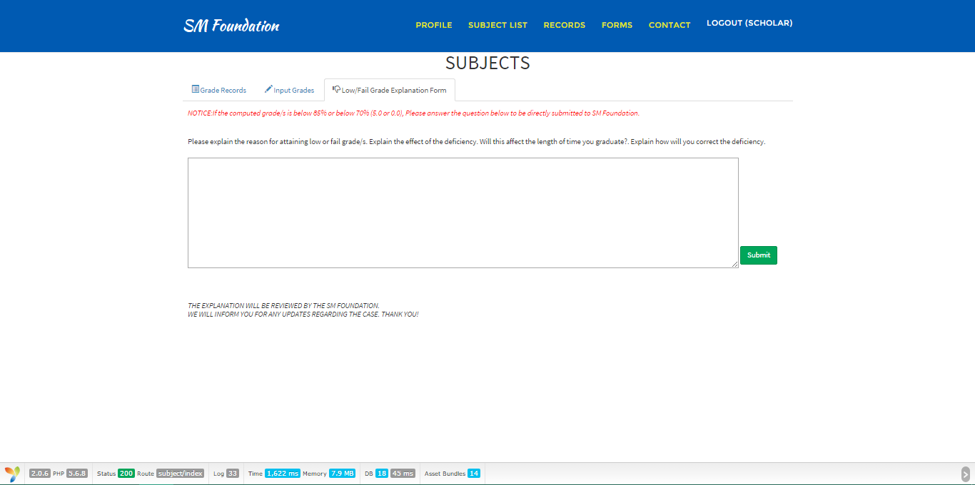Low/fail grade explanation form
     1. Go to Records > Grades
     2. Switch to Low/Fail Grade Explanation Form tab
     3. Explain the reason
     4. Hit Submit
   * 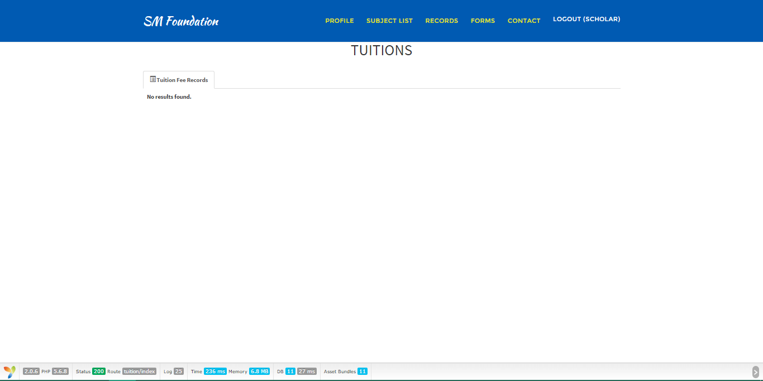view tuition fee records
     1. Go to records
     2. click view tuition fees picture menu
   * 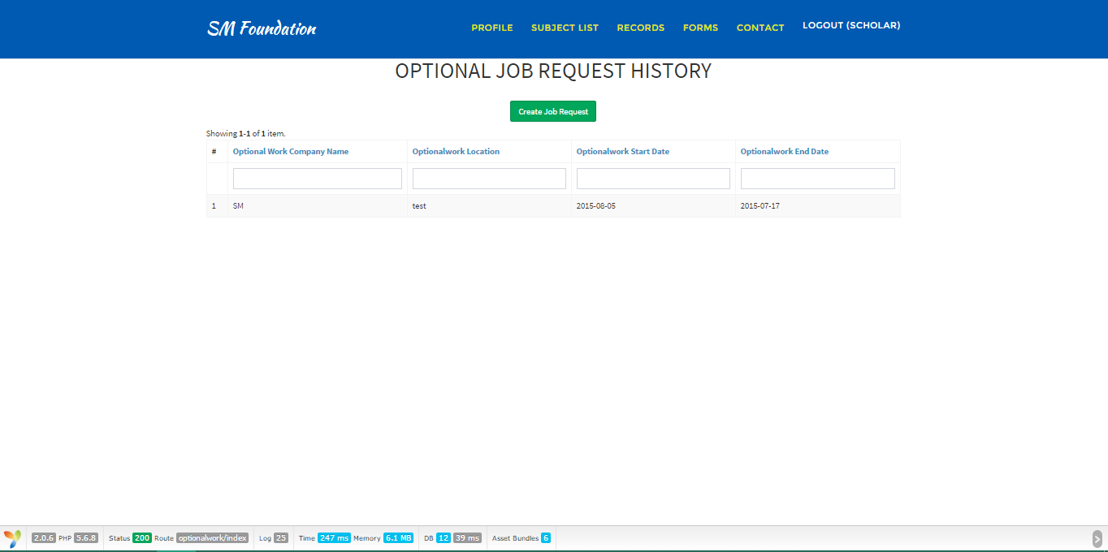create optional job request
     1. Go to Forms
     2. Click the Summer or Christmas Jobs menu
     3. Click the Create Job Request button
     4. Fill out required fields
     5. Hit Create
   * 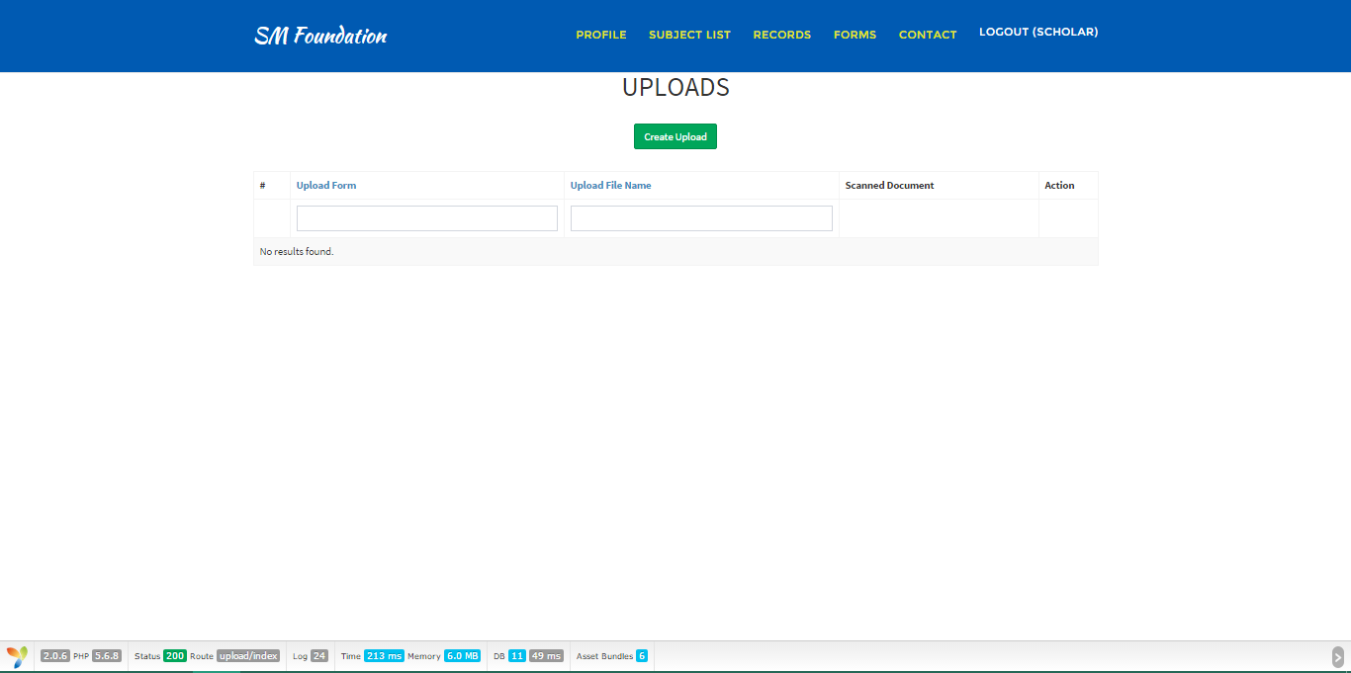Upload form/s
     1. Go to Forms
     2. Click Upload Menu
     3. Press the Create Upload button
     4. Fill out the required fields
     5. Browse for the file you want to upload
     6. Create
   * View Allowance
   * 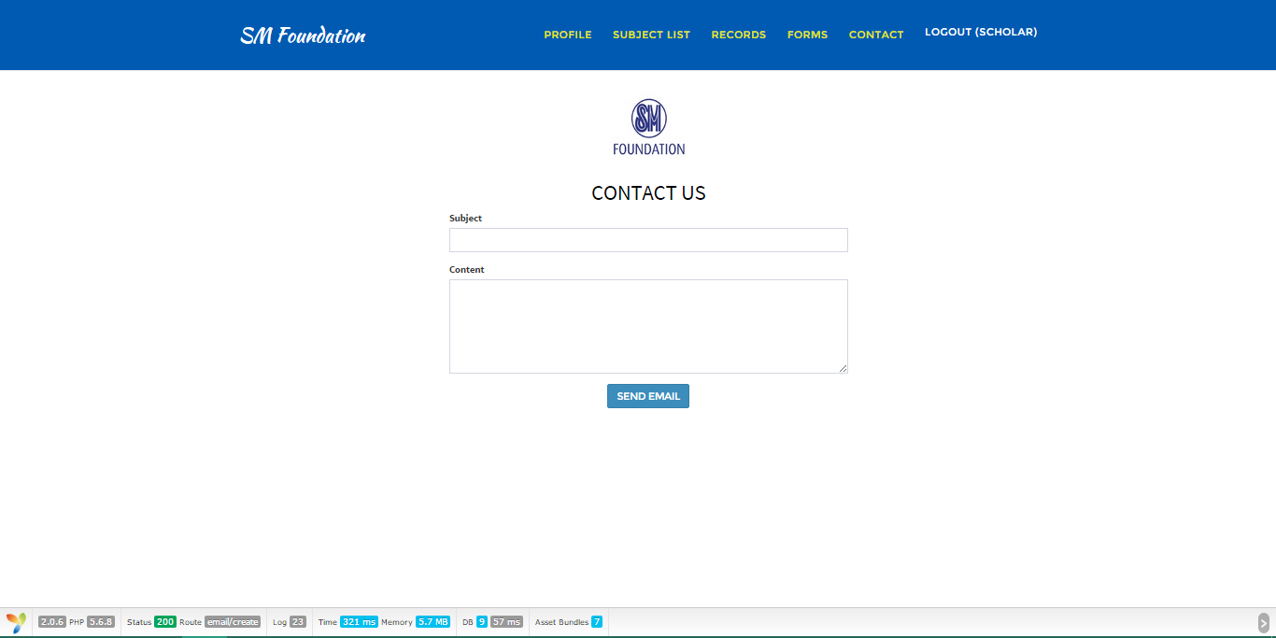contact sm foundation
     1. Go to Contact
     2. Input Subject
     3. Fill out the content
     4. Send Email
   * 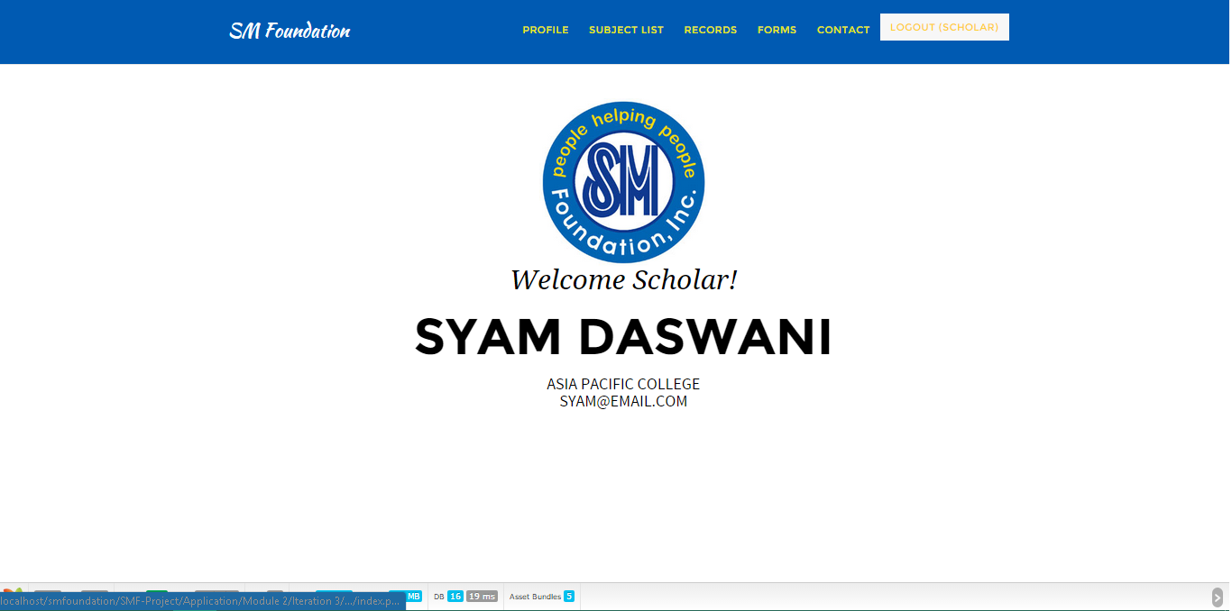Logout
   1. Click Logout

* Back-end
  + 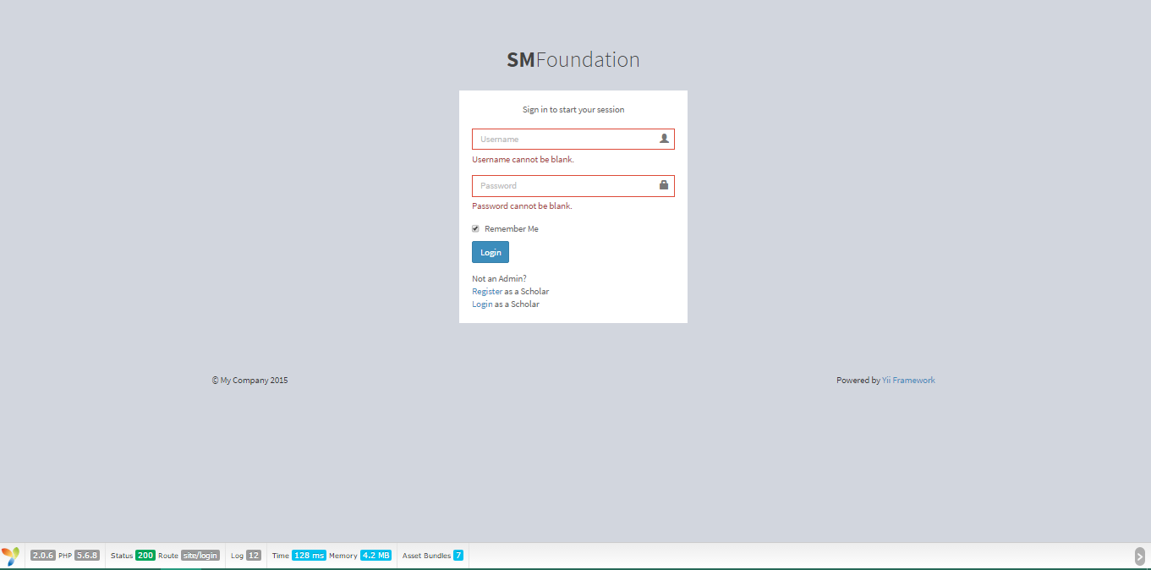Login

1. Enter Username and Password (Credentials)
2. Tick remember me checkbox if you want an autofill next login
3. Press login
   * 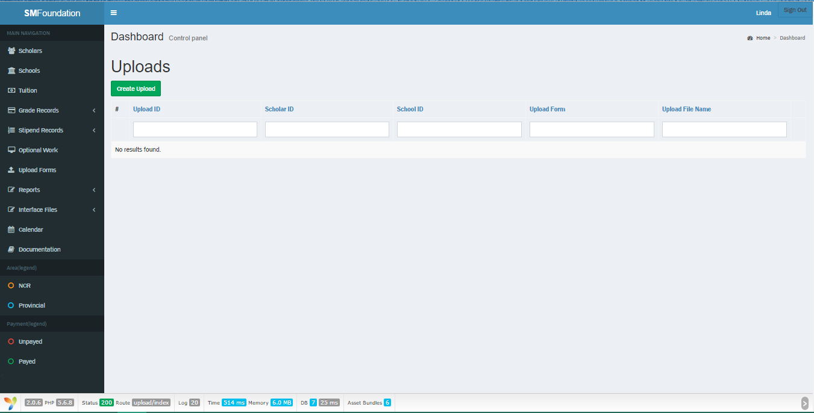upload requirements
4. Go to upload forms menu
5. Click create upload
6. Browse for the file
7. Fill out all required information
8. upload
   * Logout
   * Create record
     + Scholar

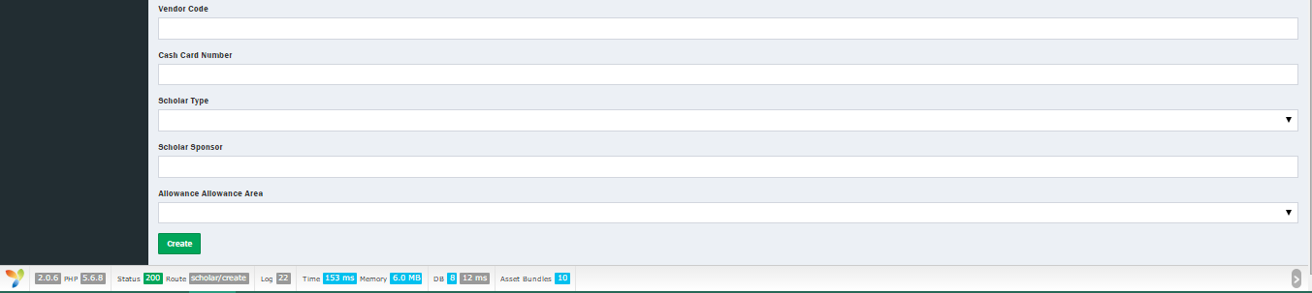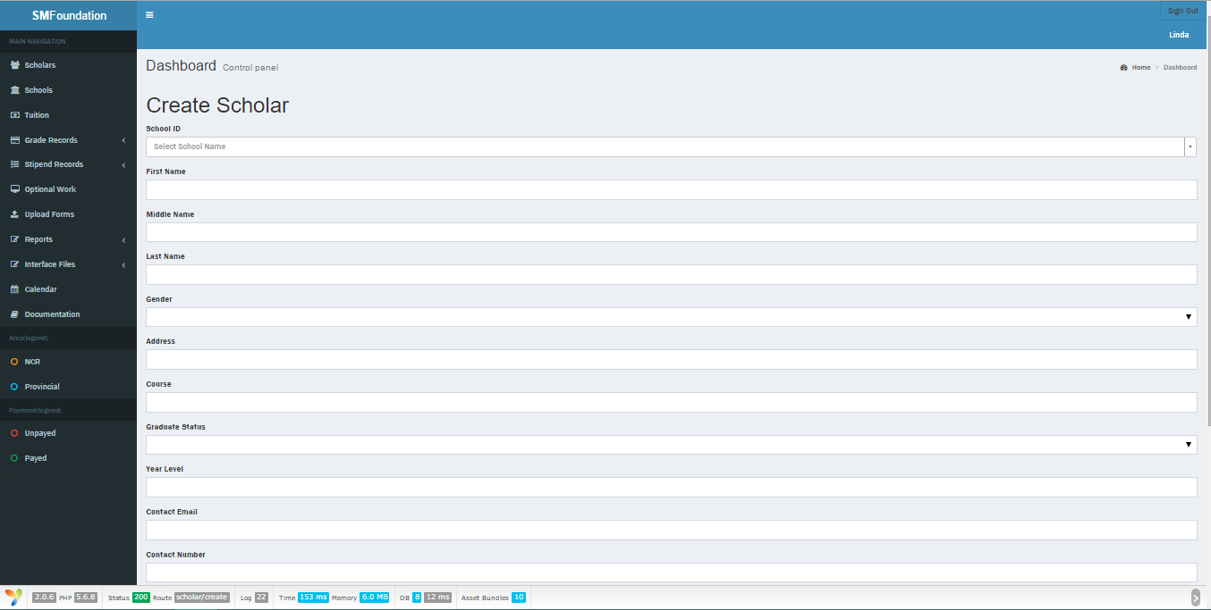

1. Go to Scholars
2. Click Create Scholar
3. Input all details asked
4. Create
   * + 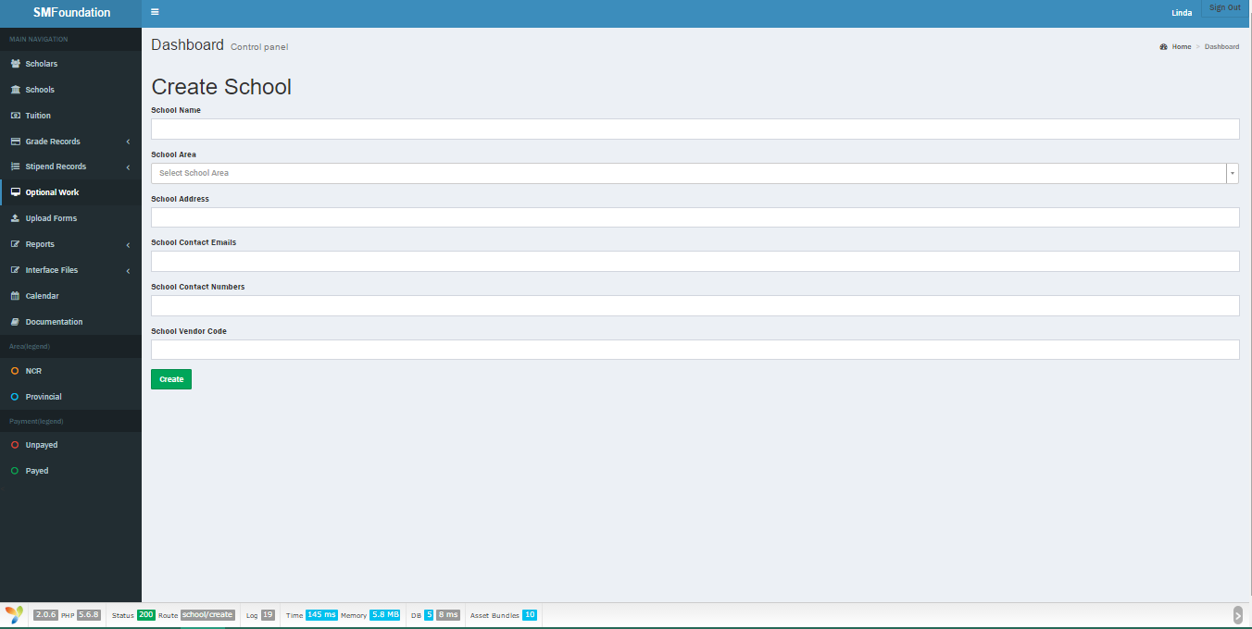School
       1. Go to Schools
       2. Click Create School
       3. Input all details required
       4. Create
     + 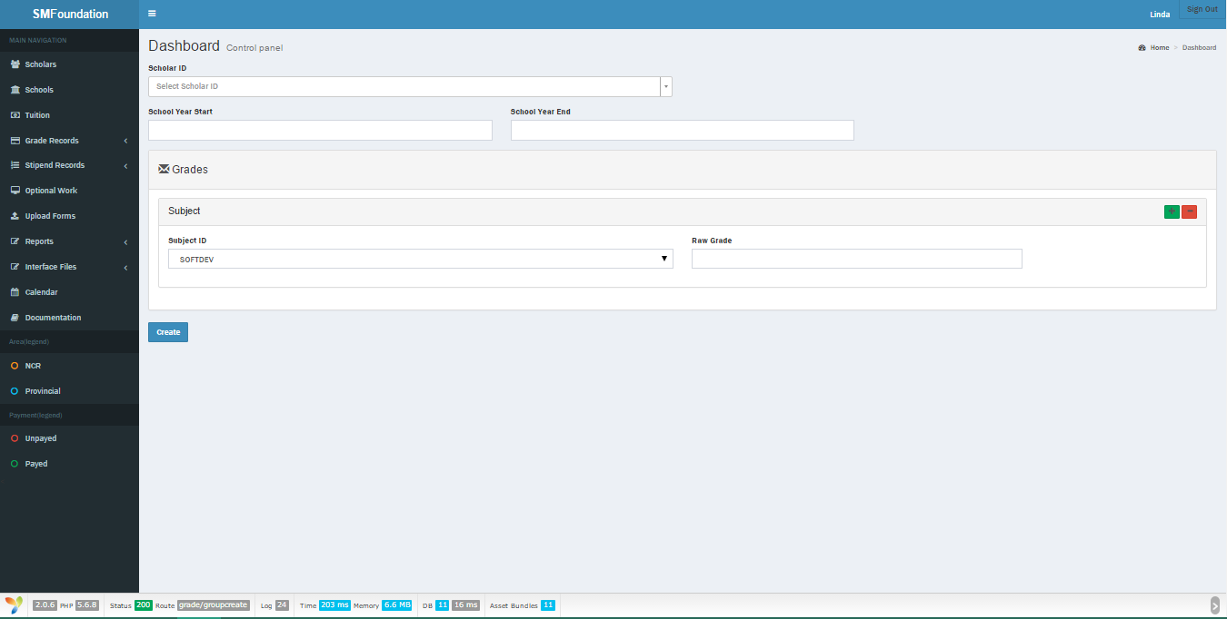Grade
     1. Go to Grade Records > Grades
     2. Create Grade
     3. Input details
     4. Create
     + 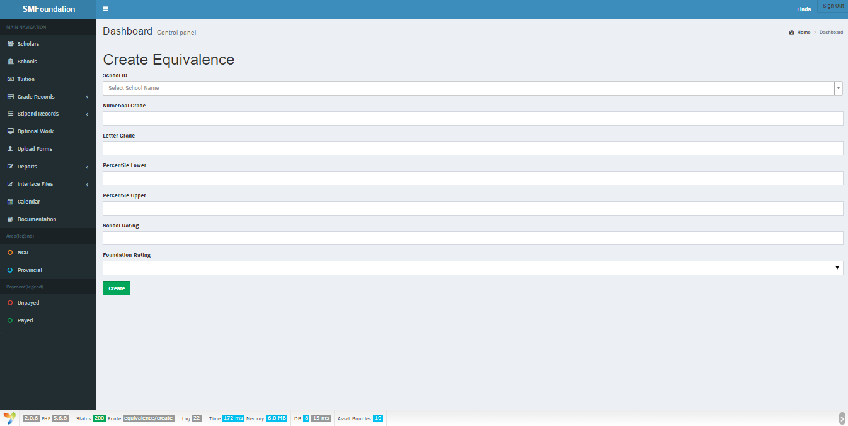Grade Equivalence
5. Go to Grade Records > Grade Equivalences
6. Create Equivalence Rule
7. Fill out fields
8. Create
   * + 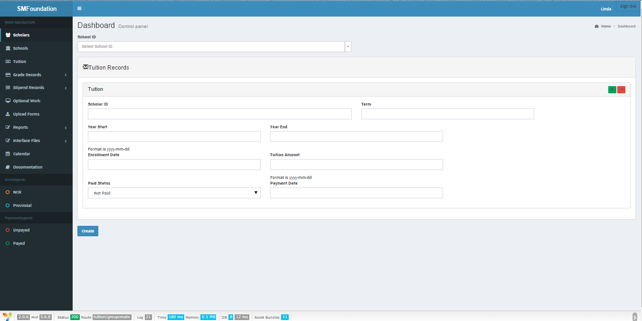Tuition
9. Go to Tuitions
10. Create Tuition
11. Fill out the fields
12. Create
    * + 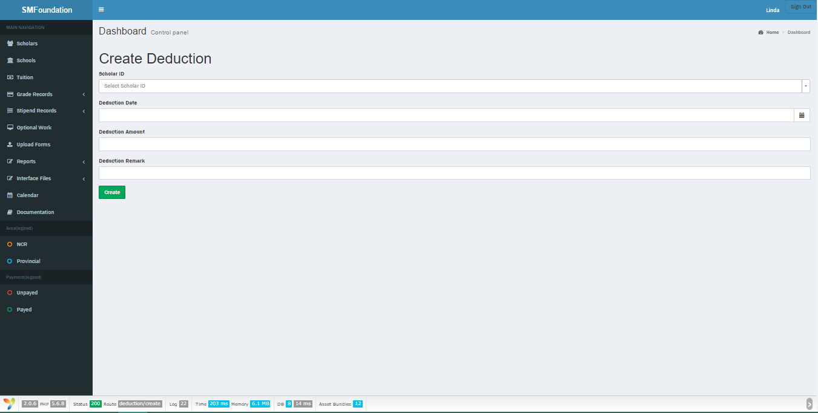Deduction
13. Go to Stipend Records > Deductions
14. Create Deduction
15. Fill out all information
16. Create
    * + 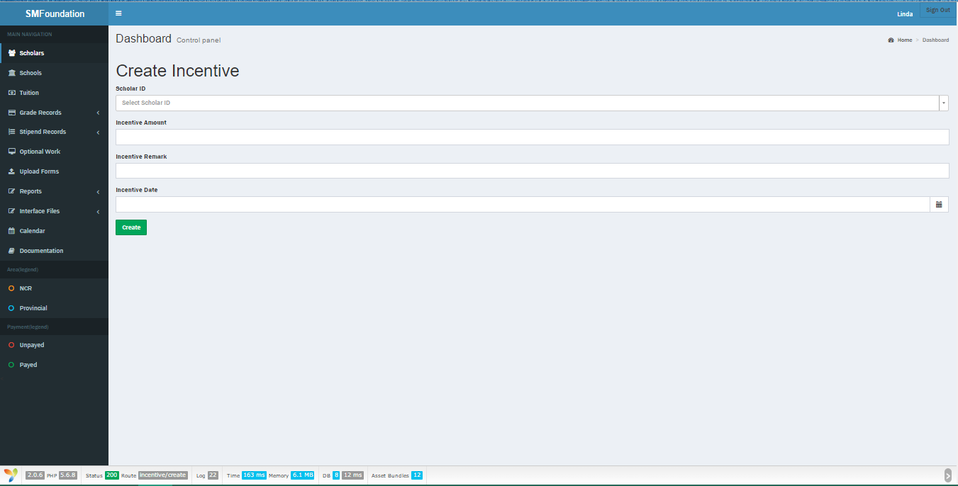Incentives
      1. Go to Stipend Records > Incentives
      2. Create Incentive
      3. Fill out all required information
      4. Create
      + 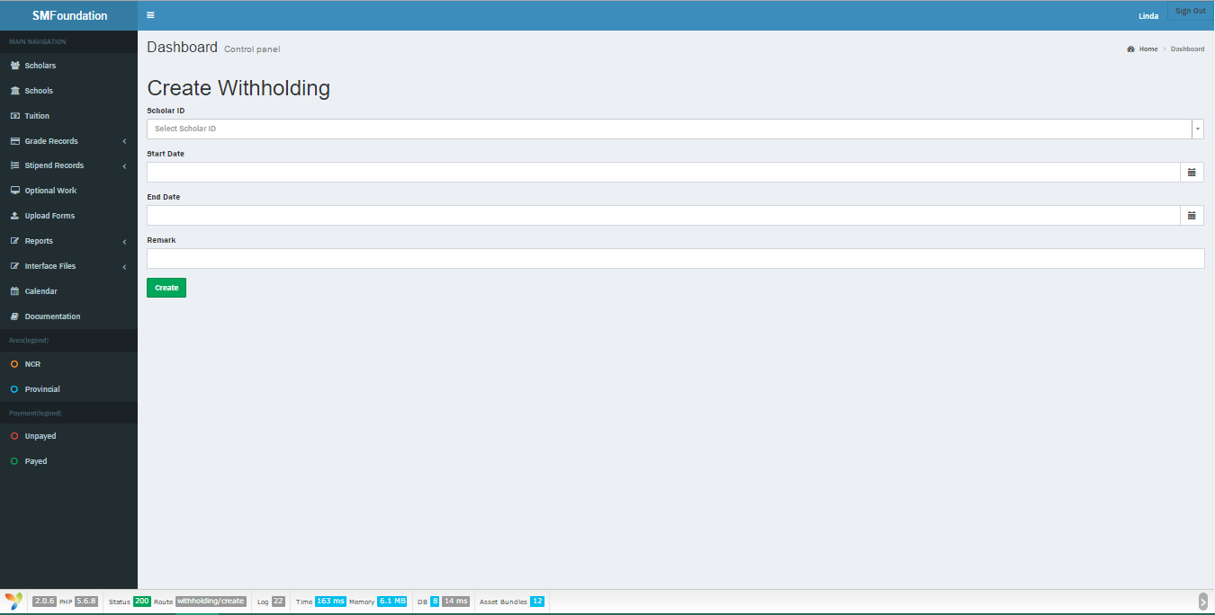Withholding
      1. Go to Stipend Records > Withholding
      2. Create Withholding Record
      3. Fill out required fields
      4. Create
      + 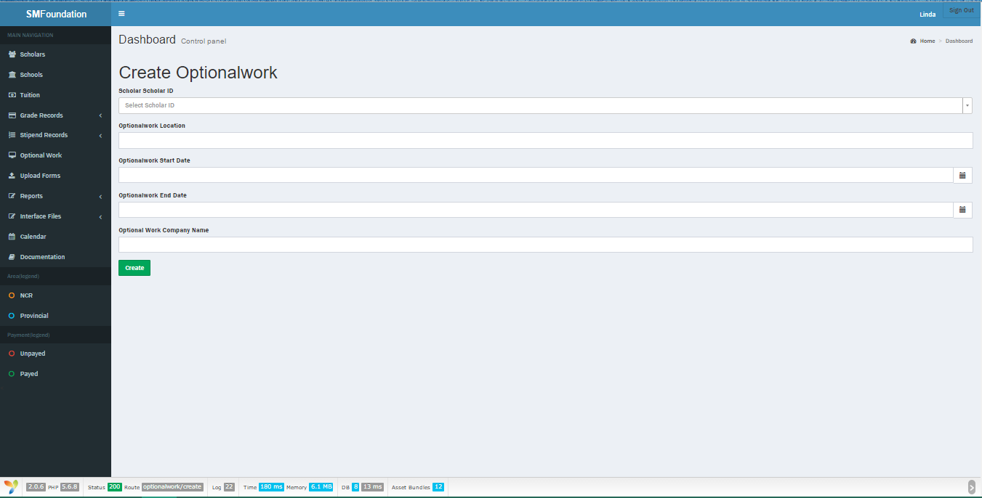Optional work
      1. Go to Optional Work
      2. Create Optional Work
      3. Fill out all fields
      4. Create
      + 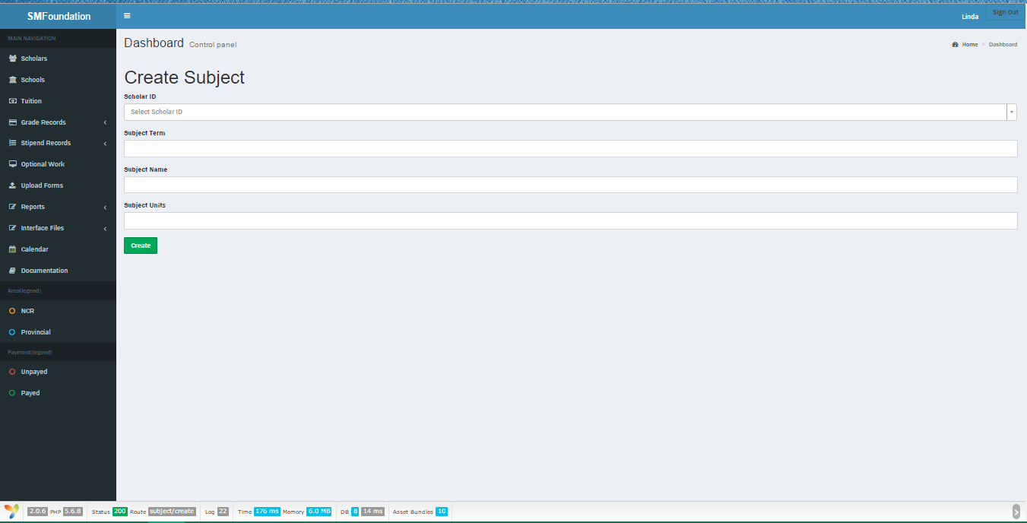Subject
      1. Go to Grade Records > Subject Records
      2. Create Subject
      3. Fill out the fields
      4. Create
    * Read record
      + 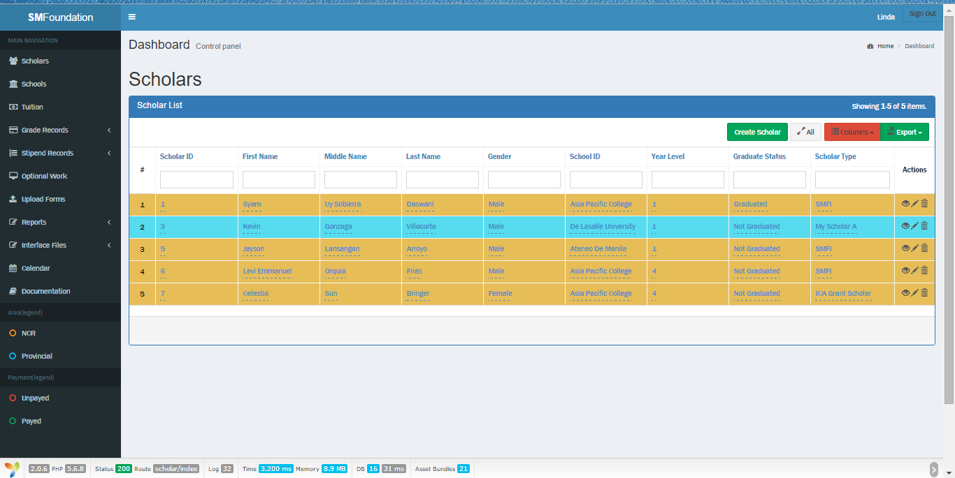Scholar
      1. Click Scholars
      + 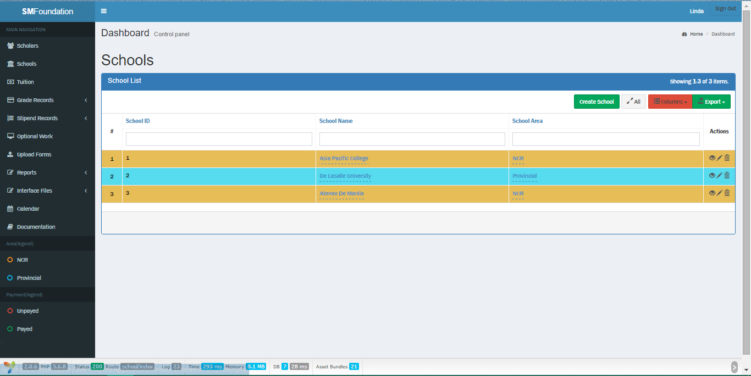School
      1. Click Schools
      + Grade (Group by Schools)

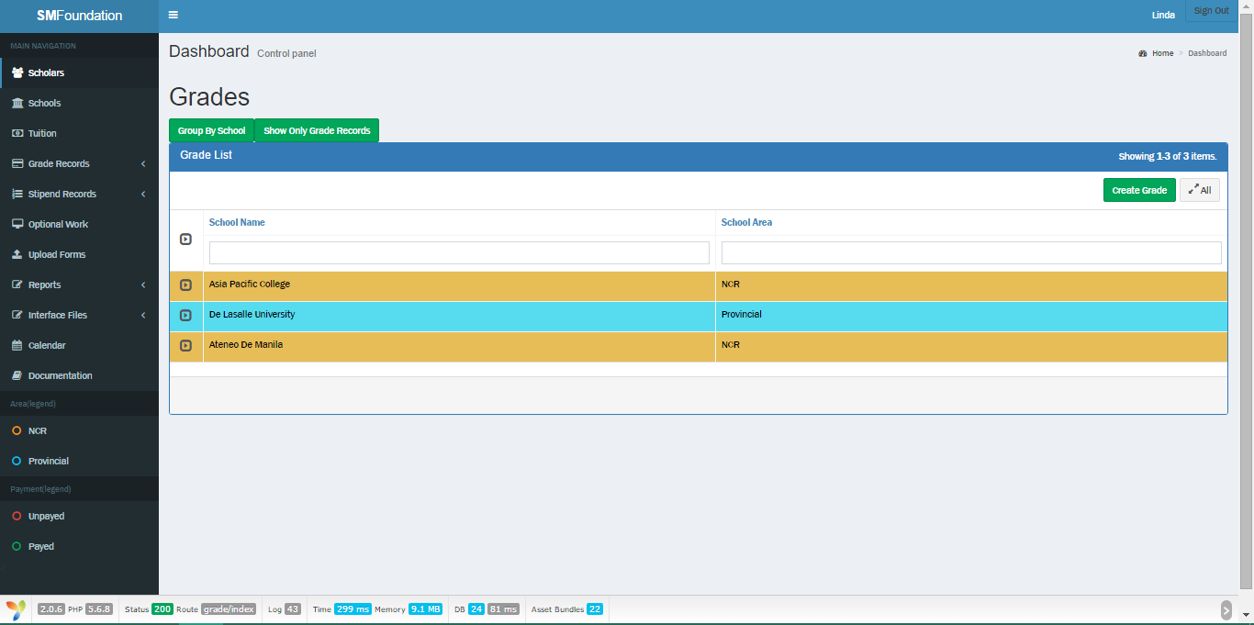

* + 1. Click Grade Records
    2. Go to Group By School Tab
* 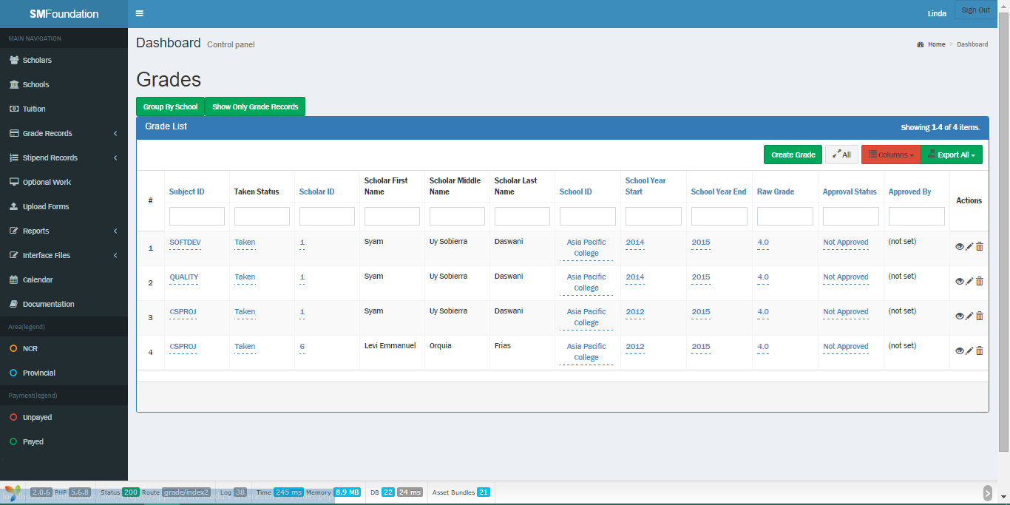Grade (Grades only)
  + 1. Go to Grade Records
    2. Click the ’ Show only Grade Records’ Tab
    - 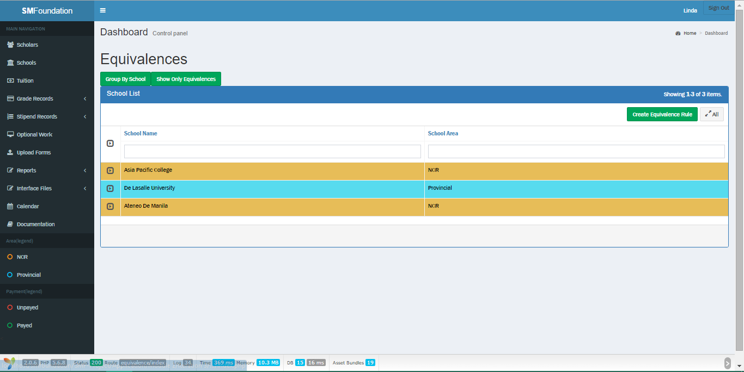Grade Equivalence (Group by school)
    1. Click Grade Records > Grading Equivalence
    2. Go to Group by School Tab
    - 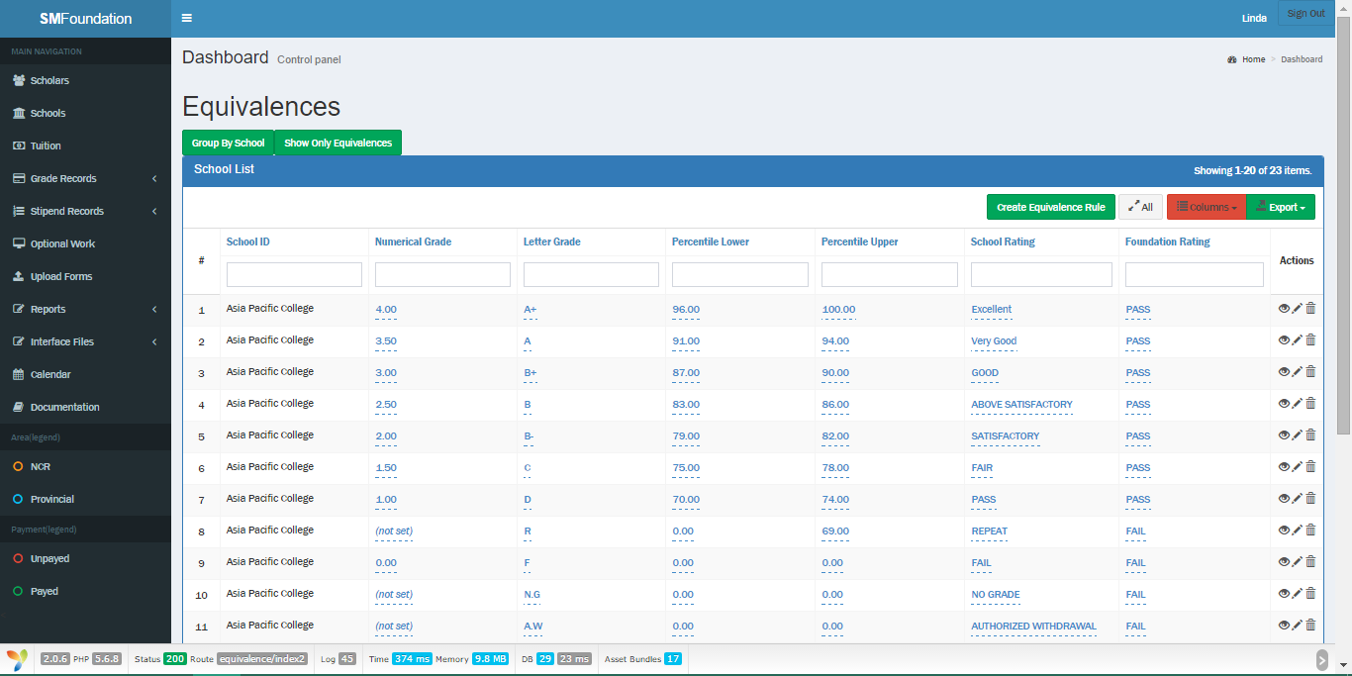Grade Equivalence (Equivalences only)
    1. Go to Grade Records > Grading Equivalence
    2. Go to Show Only Equivalences Tab
    - 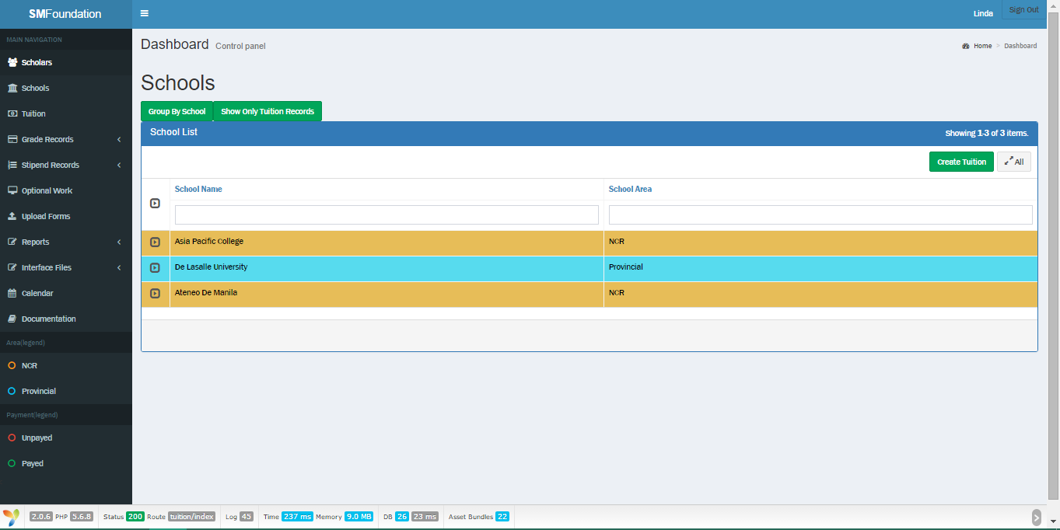Tuition (Group by Schools)
    1. Go to Tuition
    2. Click the ‘Group By School’ Tab
    - 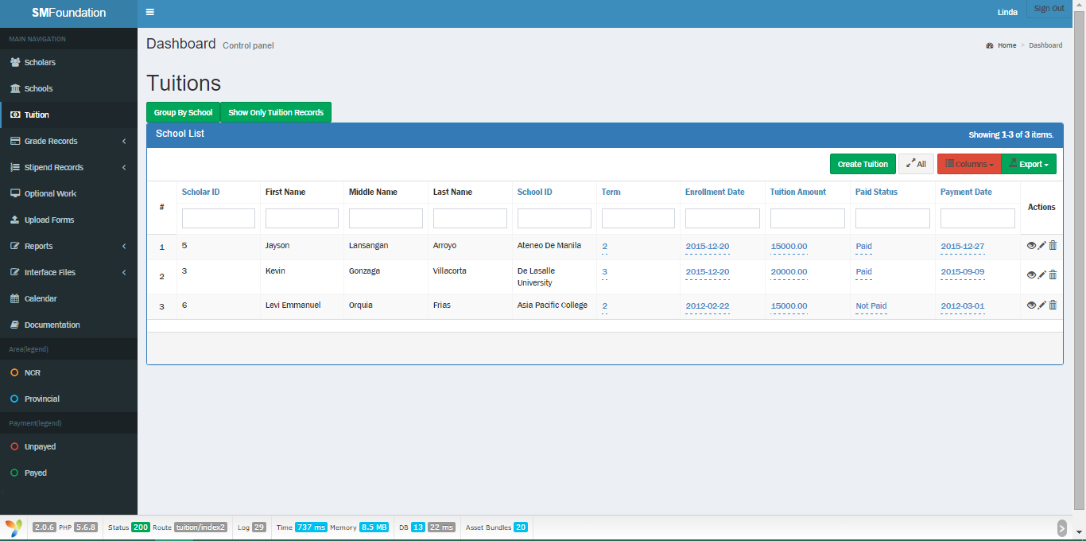Tuition (Tuition only)
    1. Go to Tuition
    2. Click the ‘Show Only Tuition Records’ tab
    - 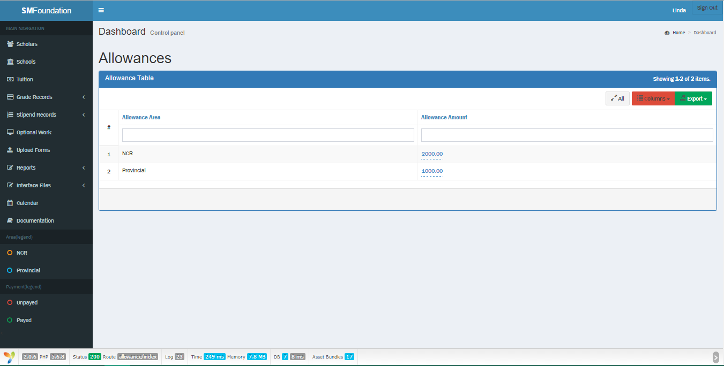Allowance
    1. Go to Stipend Records > Allowance Reference Table
    - 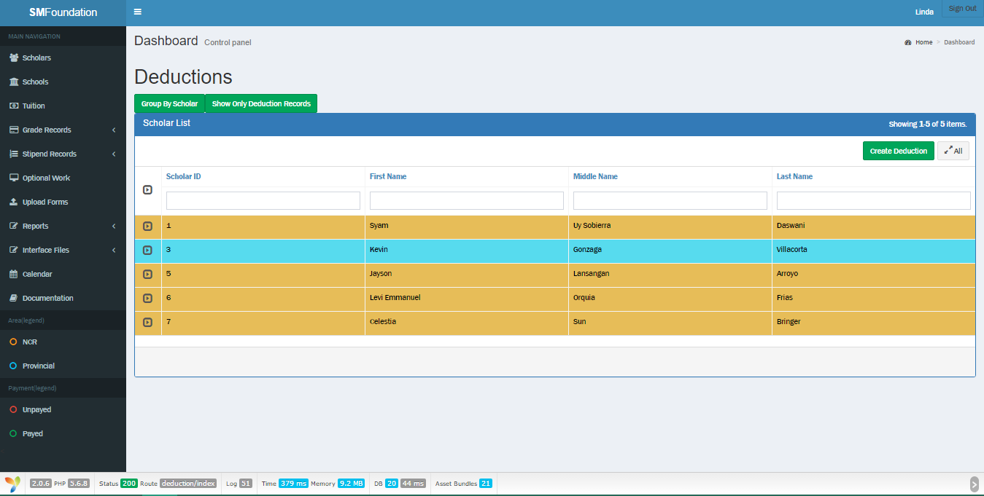Deductions (Group by Scholar)

1. Go to Stipend Records > Deductions
2. Click the ‘Group By Scholar’ Tab
   * + 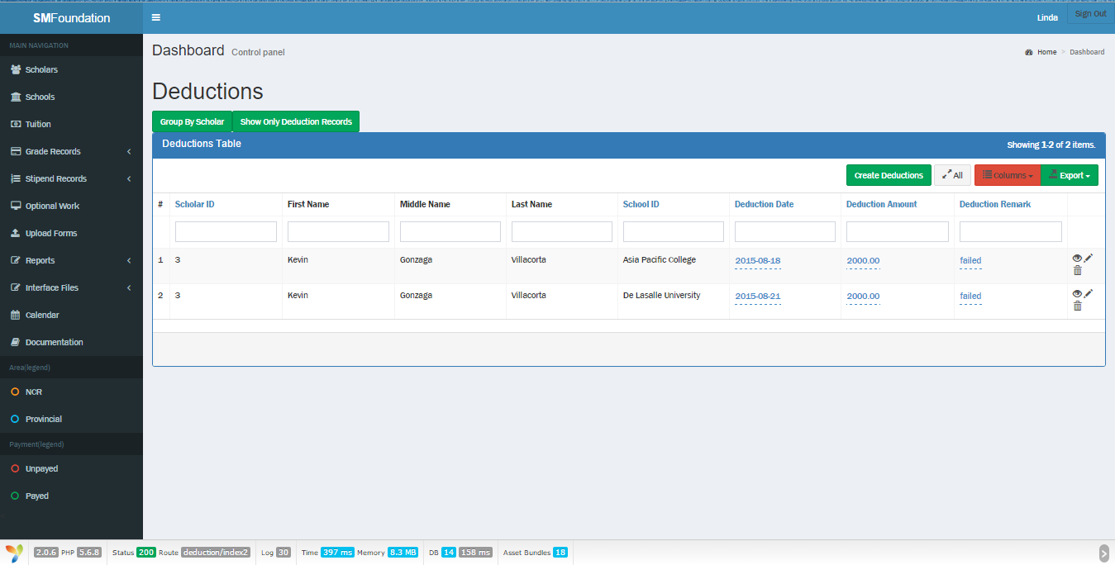Deductions (Deductions only)
     1. Go to Stipend Records > Deductions
     2. Go to Show Only Deduction Records Tab
     + 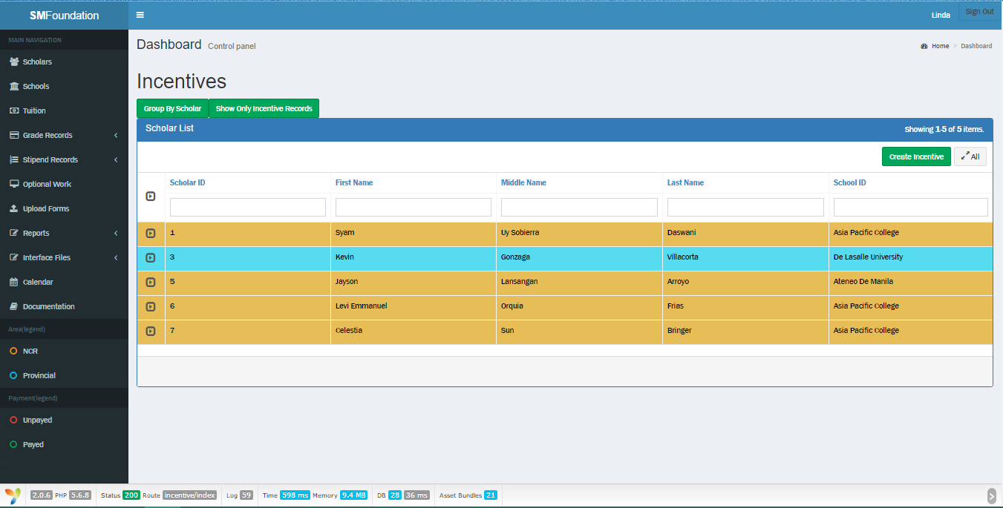Incentives (Group by Scholar)
   1. Go to Stipend Records > Incentives
   2. Go to Group By Scholar Tab
      * 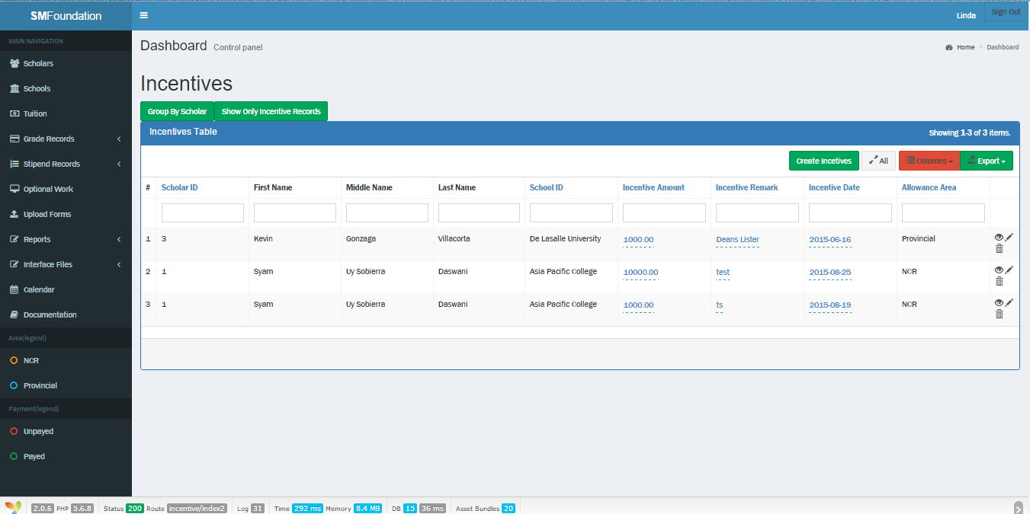Incentives (Incentives only)
      1. Go to Stipend Records > Incentives
      2. Go to Show Only Incentive Records Tab
      * 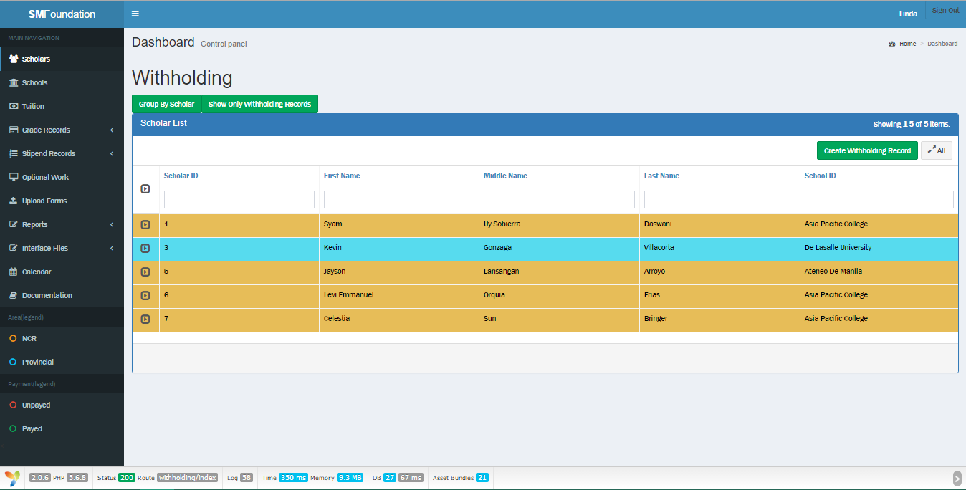Withholding (Group by Scholar)
      1. Go to Stipend Records > Withholding
      2. Click the ‘Group By Scholar’ tab
      * 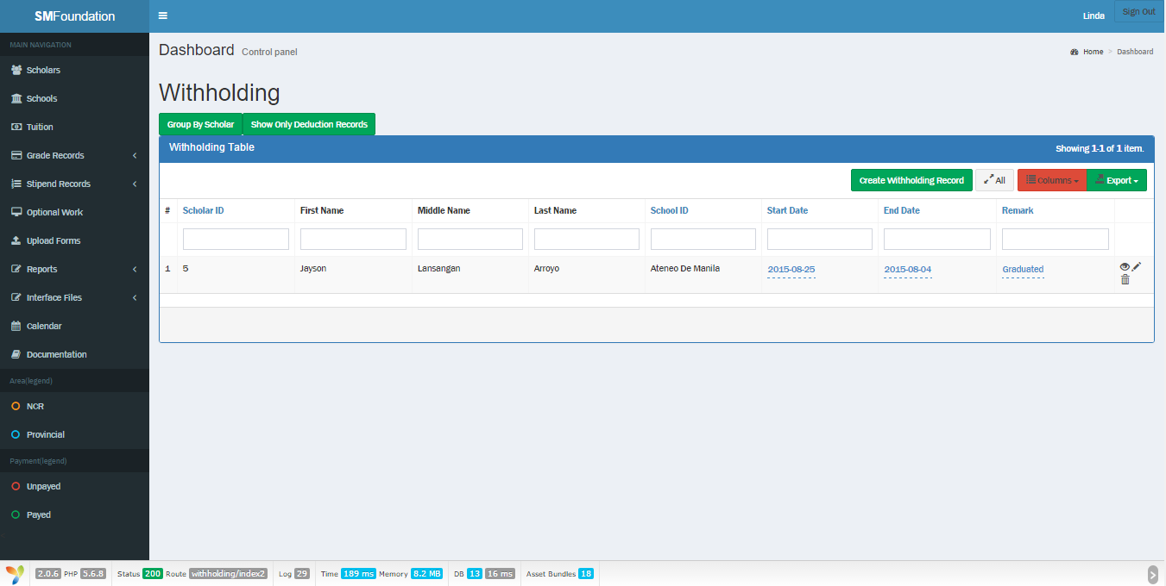Withholding (Deductions only)
      1. Go to Stipend Records > Withholding
      2. Click the ‘Show Only Deduction Records’ tab
      * 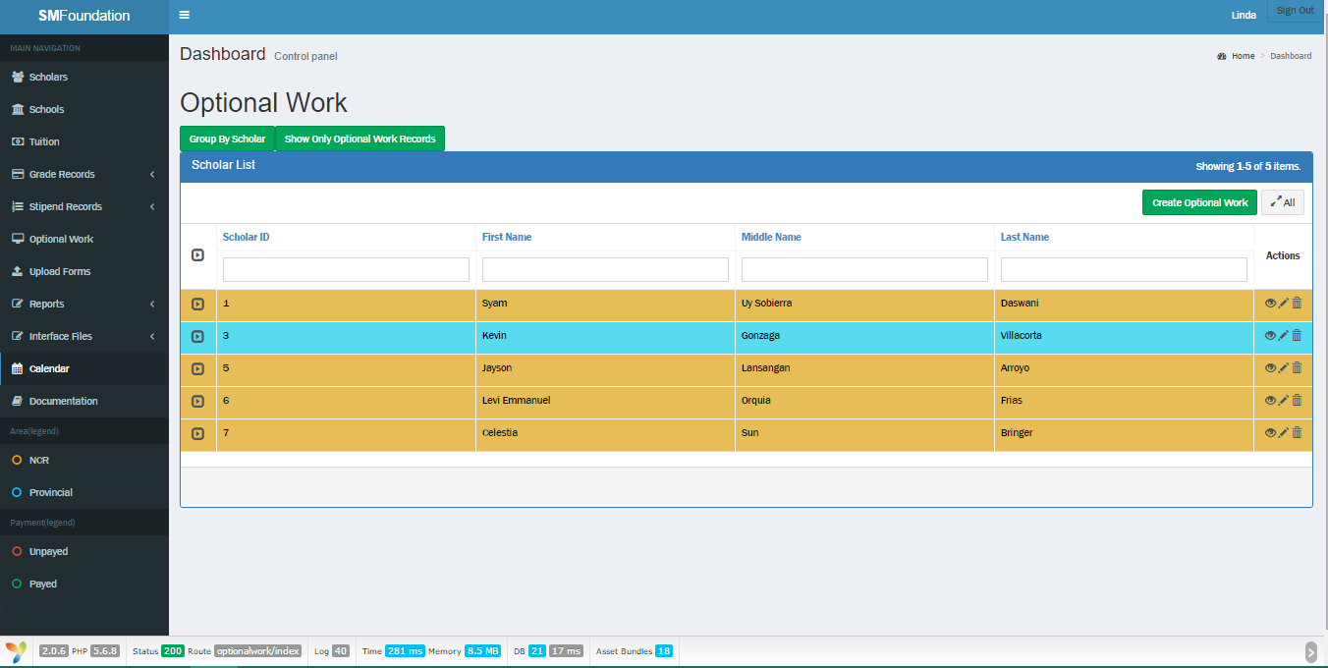Optional work (Group by Scholar)
      1. Go to Optional Work
      2. Go to Group By Scholar Tab
      * 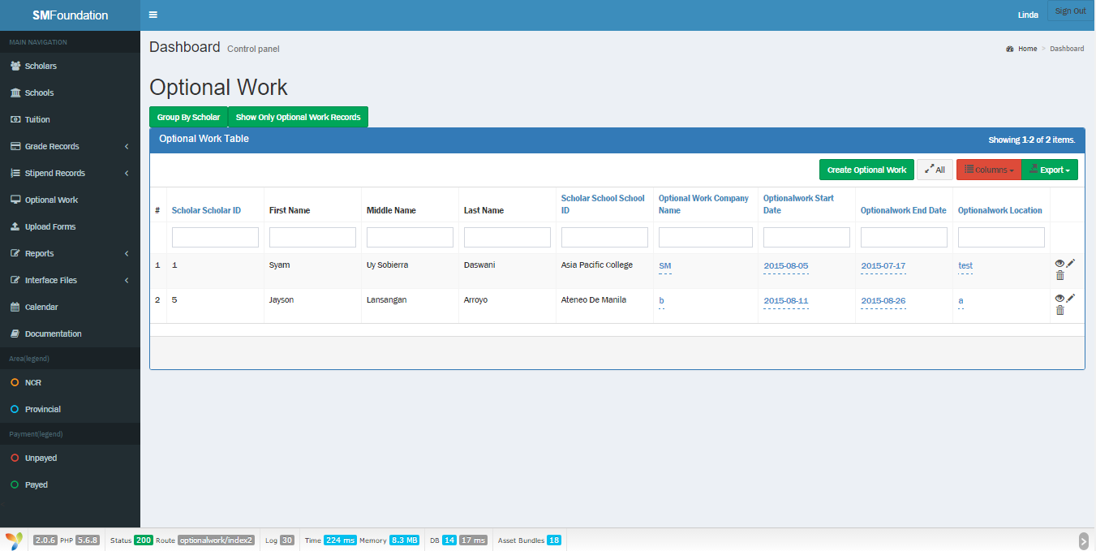Optional Work (Optional Work only)
      1. Go to Optional Work
      2. Go to Show Only Optional Work Records Tab
      * 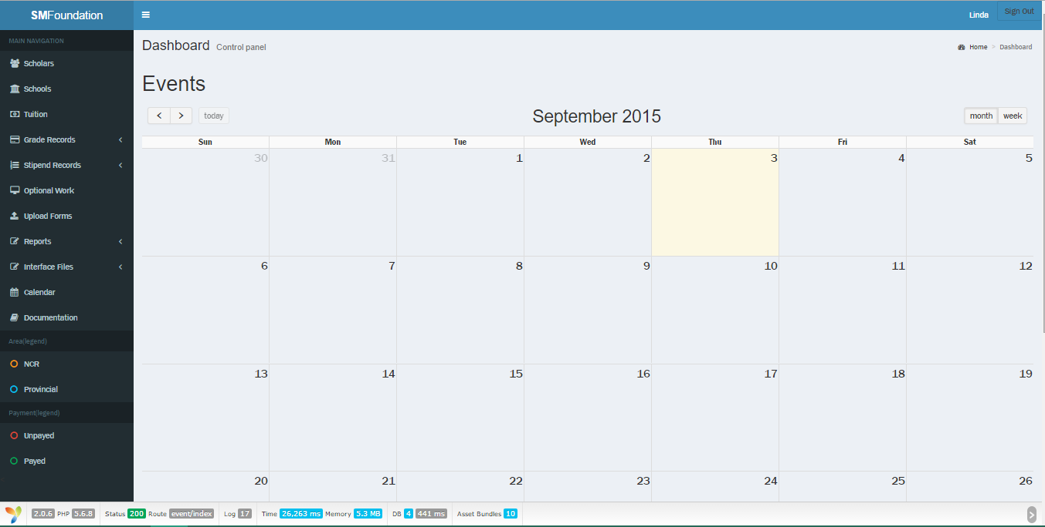Calendar (Monthly)
      1. Go to Calendar (Month is set by default)
      2. If it is set on weekly, click the ‘month’ button on upper right
      * 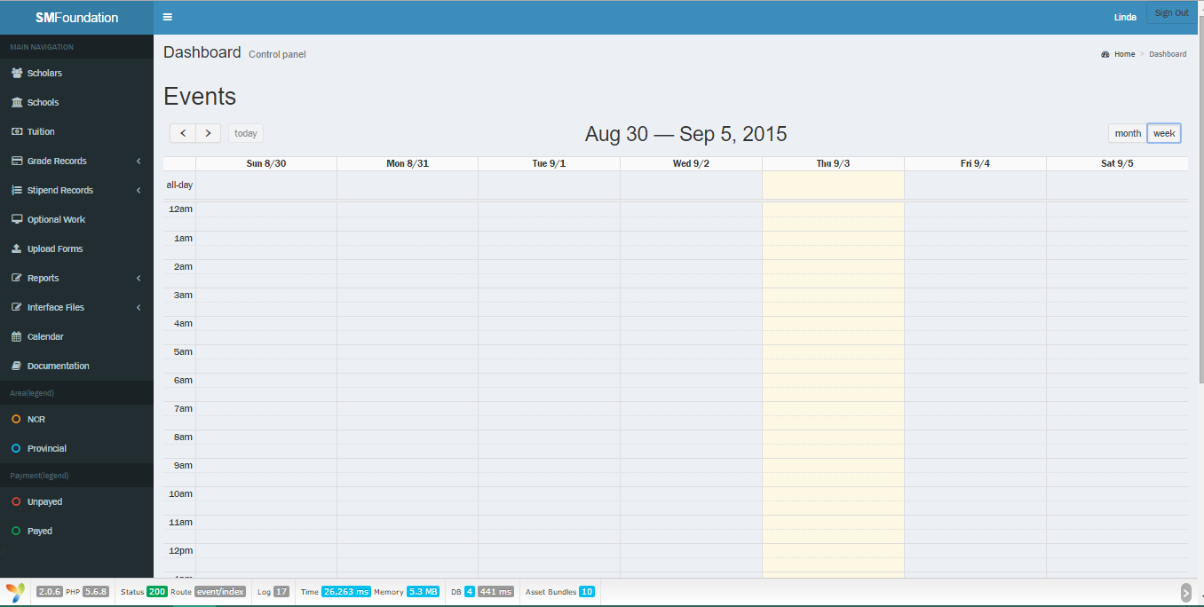Calendar (Weekly)
      1. Go to Calendar
      2. Click ‘Week’ button on the upper right
      * 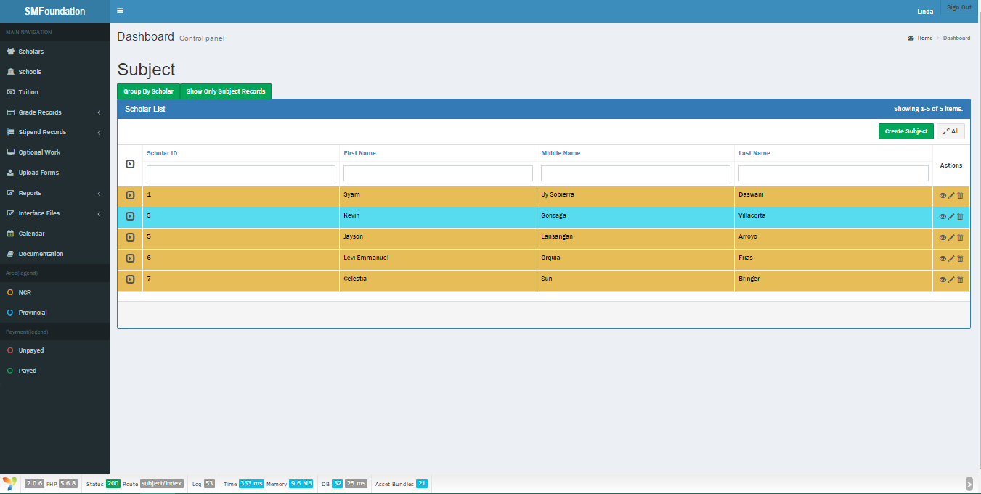Subject (Group by Scholar)
      1. Go to Grade Records > Subject Records
      2. Go to Group By Scholar Tab
      * Subject (Subject records only)

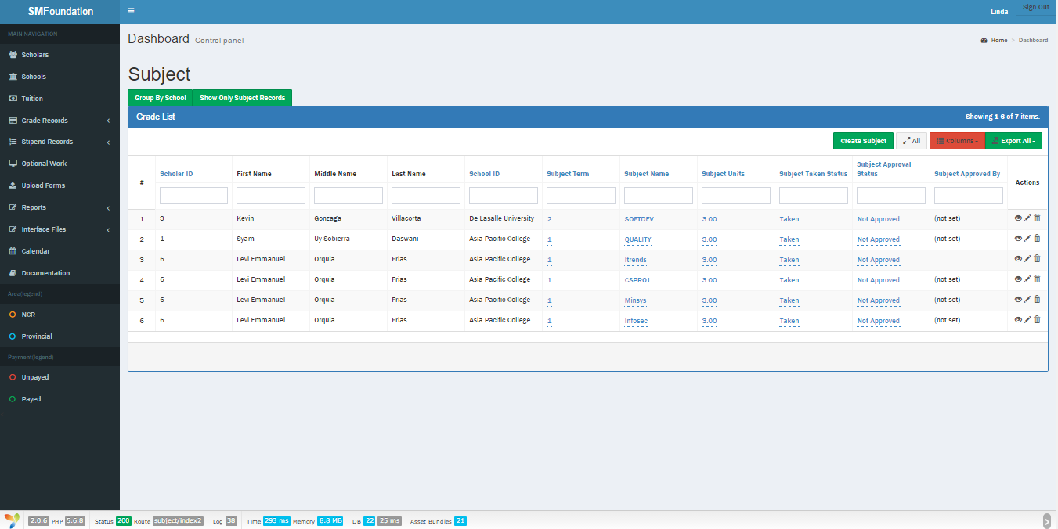

* + 1. Click the Grade Records > Subject Records
    2. Go to Show Only Subject Records Tab
  + Update record
    - 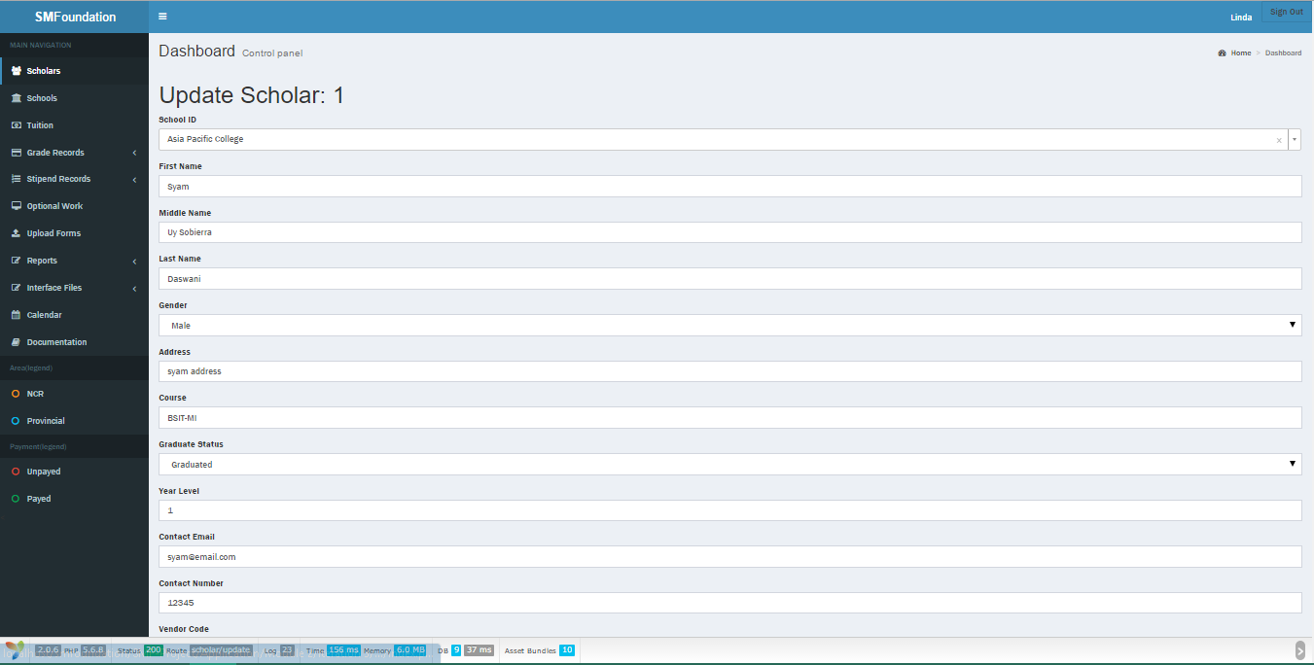Scholar

1. Go to Scholars
2. Go to Actions and click the pen image or
   * + 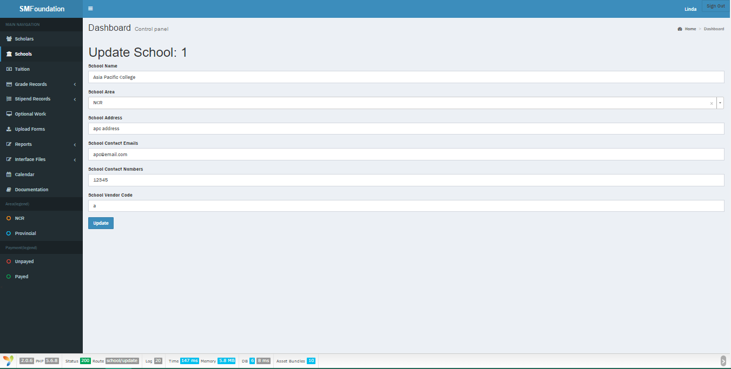School
3. Go to Schools
4. In the Actions, click the Pen image
   * + 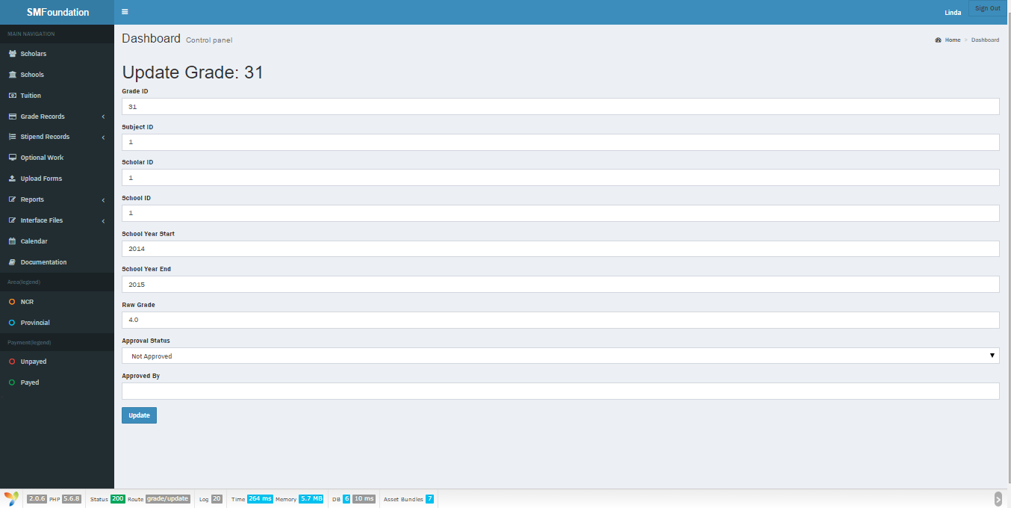Grade
5. Go to Grade Records > Grades
6. Hover to the arrow button on the left that displays ‘Expand’
7. In the Actions > Choose the Pen image or
8. Switch to Show Only Grade Records Tab
9. In the Actions, Click the Pen image
   * + 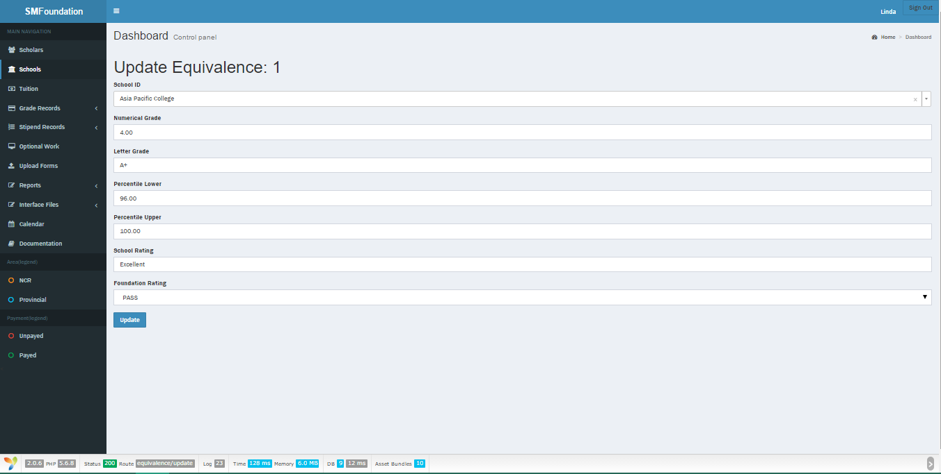Grade Equivalence
10. Go to Grade Records > Grading Equivalence
11. Hover to the arrow button on the left that displays ‘Expand’
12. In the Actions > Choose the Pen image or
13. Switch to Show Only Equivalences Tab
14. In the Actions, Click the Pen image
    * + 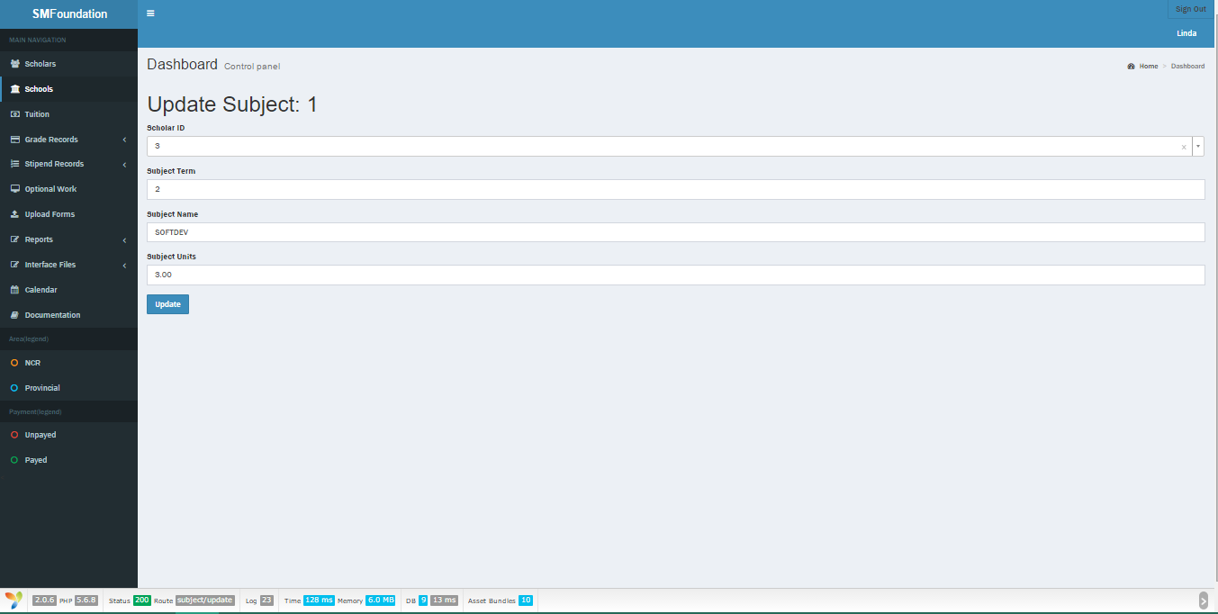Subject
15. Go to Grade Records > Subject Records
16. Hover to the arrow button on the left that displays ‘Expand’
17. In the Actions > Choose the Pen image or
18. Switch to Show Only Subject Records Tab
19. In the Actions, Click the Pen image
    * + 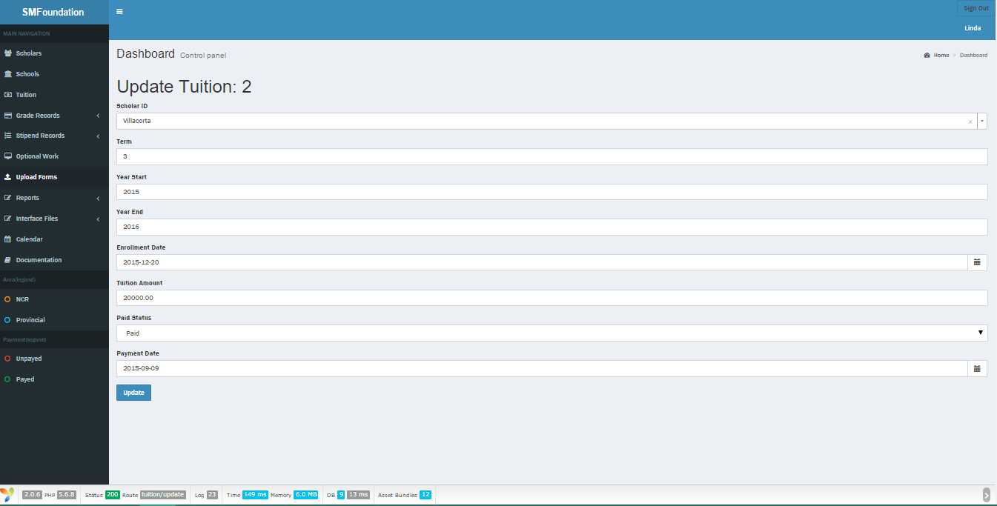Tuition
20. Go to Tuition
21. Hover to the arrow button on the left that displays ‘Expand’
22. In the Actions > Choose the Pen image or
23. Switch to Show Only Tuition Records Tab
24. In the Actions, Click the Pen image
    * + 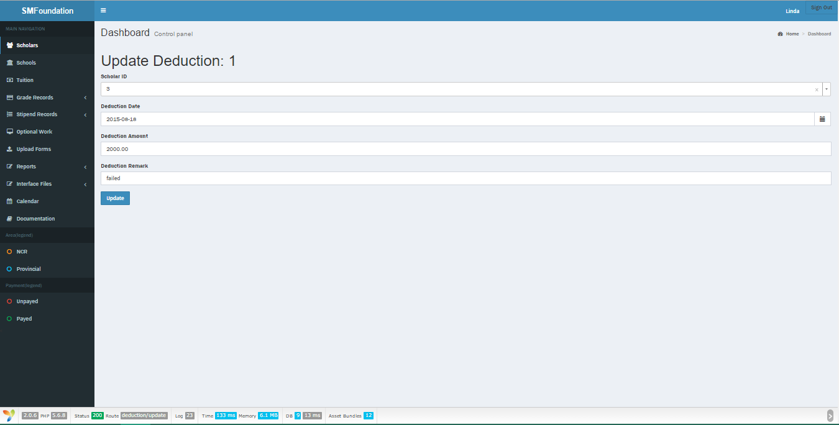Deduction
25. Go to Stipend Records > Deductions
26. Hover to the arrow button on the left that displays ‘Expand’
27. In the Actions > Choose the Pen image or
28. Switch to Show Only Deduction Records Tab
29. In the Actions, Click the Pen image
    * + 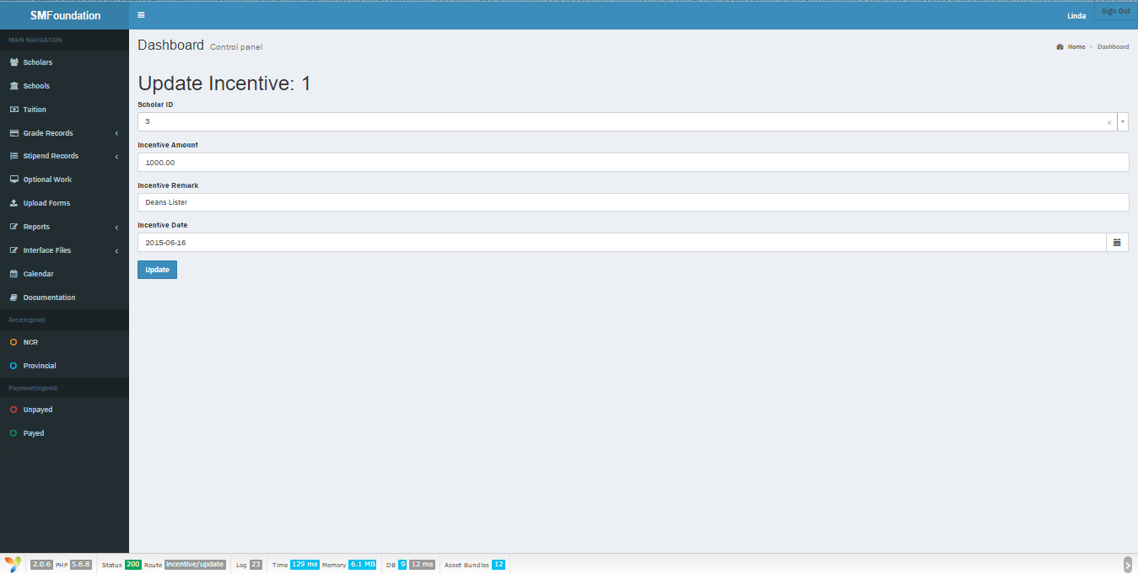Incentive
        1. Go to Stipend Records > Incentives
        2. Hover to the arrow button on the left that displays ‘Expand’
        3. In the Actions > Choose the Pen image or
        4. Switch to Show Only Incentive Records Tab
        5. In the Actions, Click the Pen image
      + 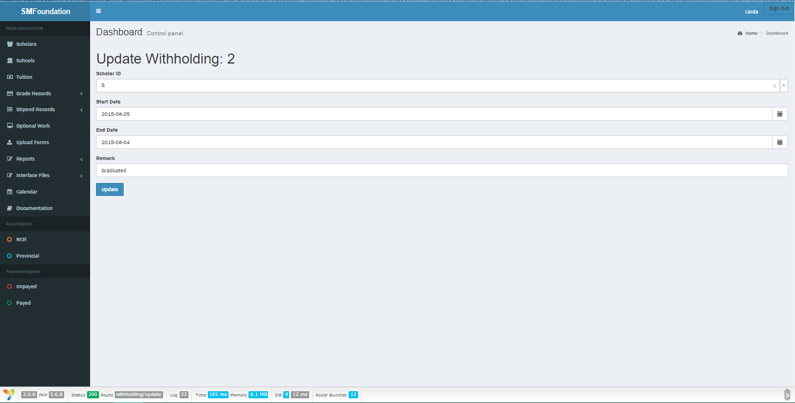Withholding
30. Go to Stipend Records > Withholding
31. Hover to the arrow button on the left that displays ‘Expand’
32. In the Actions > Choose the Pen image or
33. Switch to Show Only Withholding Records Tab
34. In the Actions, Click the Pen image
    * + 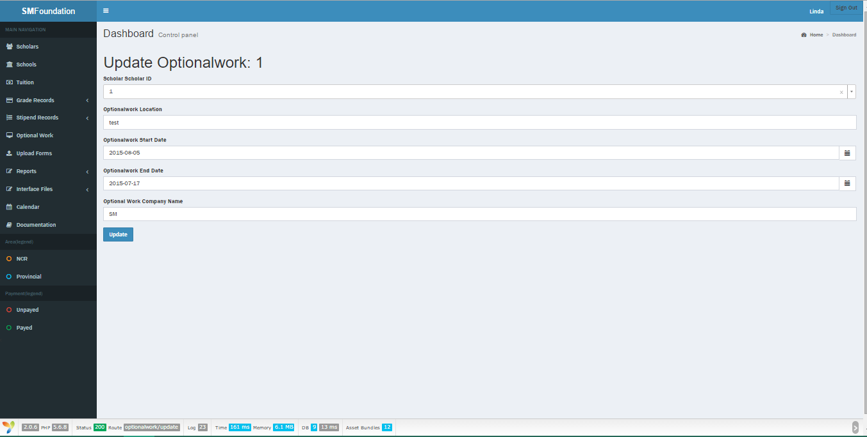Optional work
35. Go to Optional Work
36. Hover to the arrow button on the left that displays ‘Expand’
37. In the Actions > Choose the Pen image or
38. Switch to Show Only Optional Work Records Tab
39. In the Actions, Click the Pen image
    * Delete record
      + 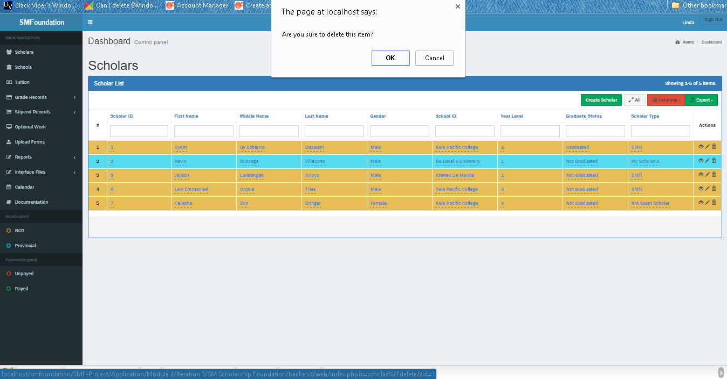Scholar
        1. Go to Scholars
        2. In Actions column, select the trash bin image
        3. A pop-up confirmation will appear. If certain, click yes; otherwise, cancel.
      + 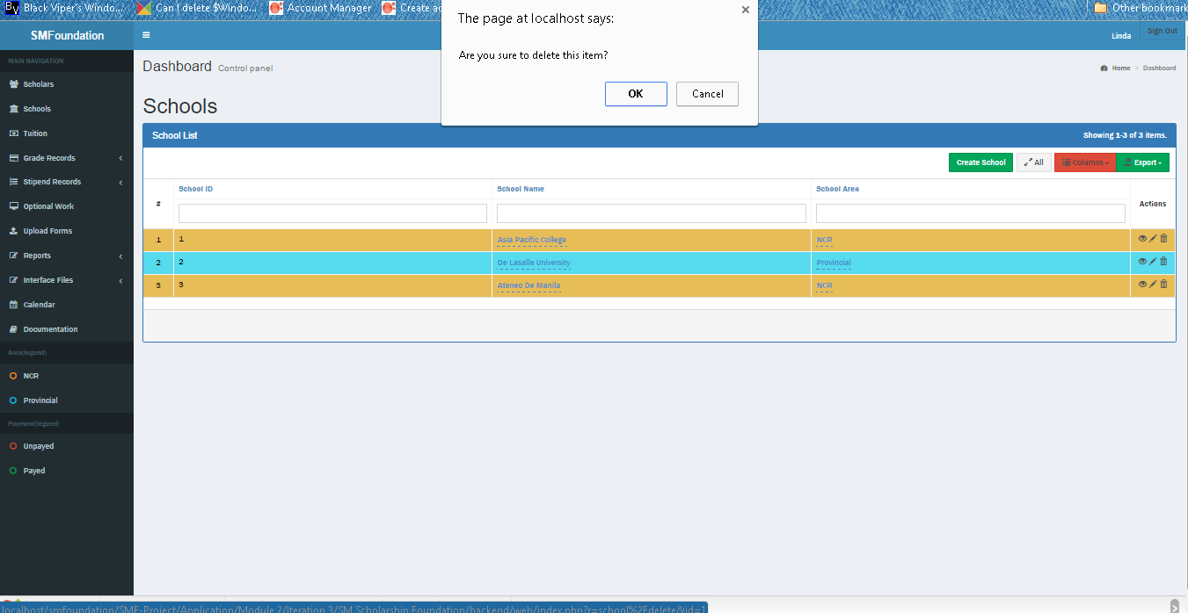School
        1. Go to Schools
        2. In Actions column, select the trash bin image
        3. A pop-up confirmation will appear. If certain, click yes; otherwise, cancel.
      + Grade (Group by School)

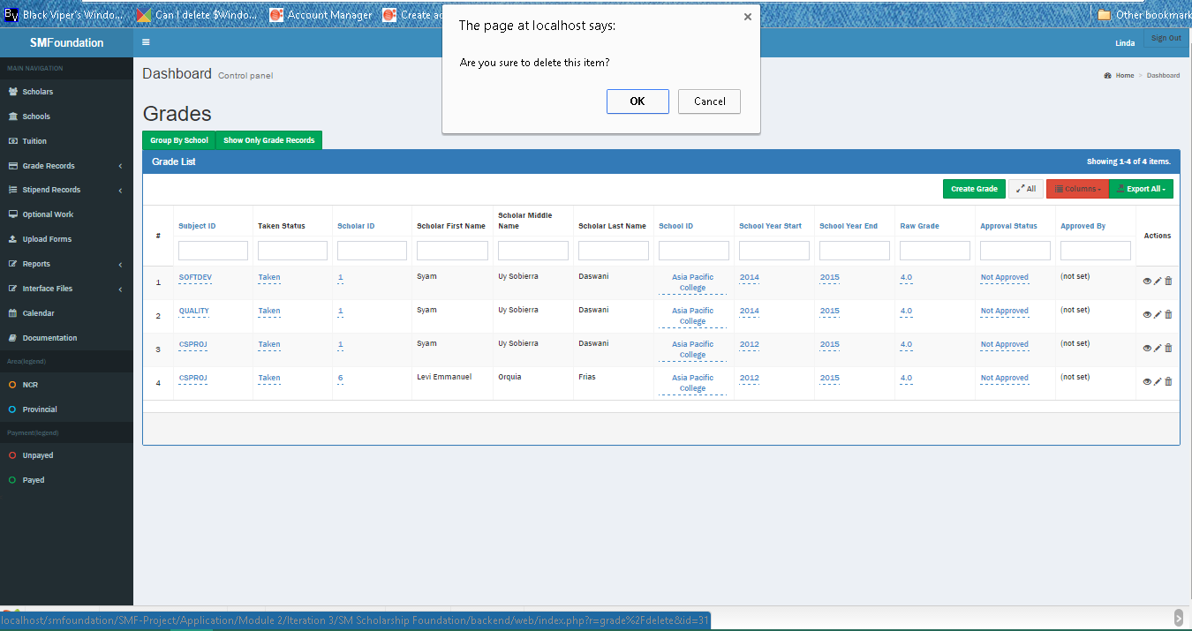

1. Go to Grade Records > Grades
2. Hover to the arrow button on the left that displays ‘Expand’
3. In the Actions > Choose the trash bin image
4. A pop-up confirmation will appear. If certain, choose yes; otherwise, cancel
   * + Grade (Grades only)
5. Switch to Show Only Grade Records Tab
6. In the Actions, Click the trash bin image
7. A pop-up confirmation will appear.
8. Choose
   * + Grade Equivalence (Group by School)

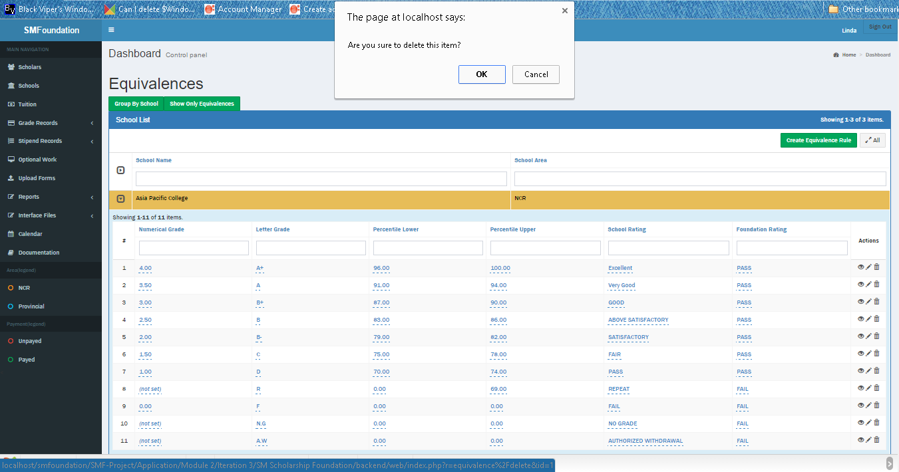

1. Go to Grade Records > Grading Equivalence
2. Hover to the arrow button on the left that displays ‘Expand’
3. In the Actions > Choose the trash bin image
4. A pop-up confirmation will appear. If certain, choose yes; otherwise, cancel
   * + 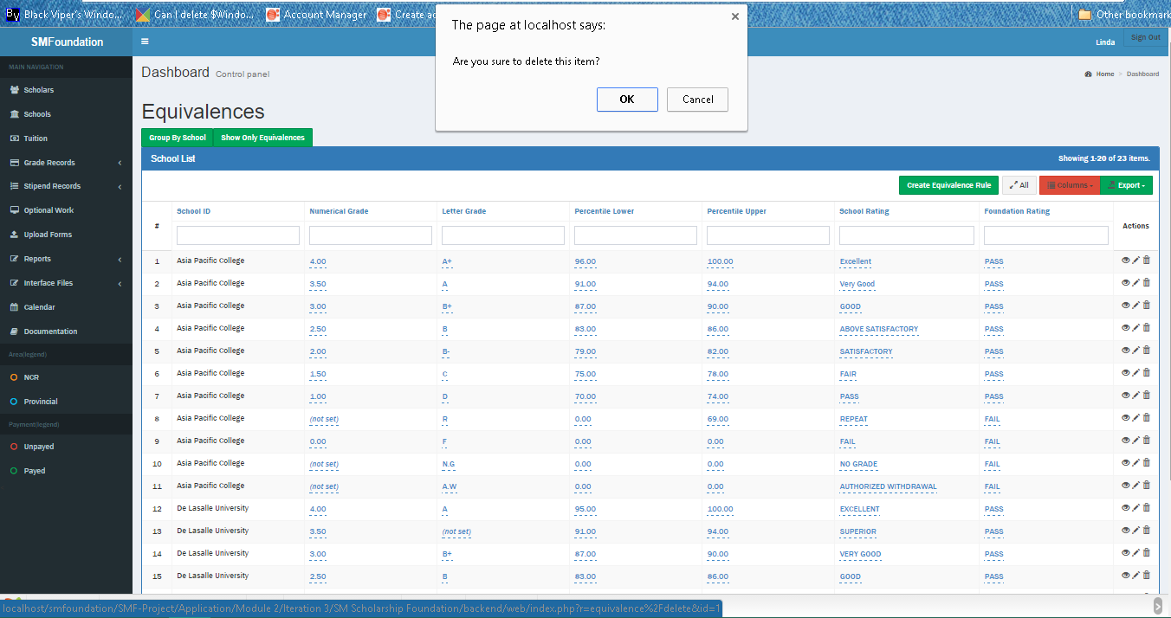Grade Equivalence (Equivalences only)
5. Switch to Show Only Equivalences Tab
6. In the Actions, Click the trash bin image
7. A pop-up confirmation will appear.
8. Choose
   * + 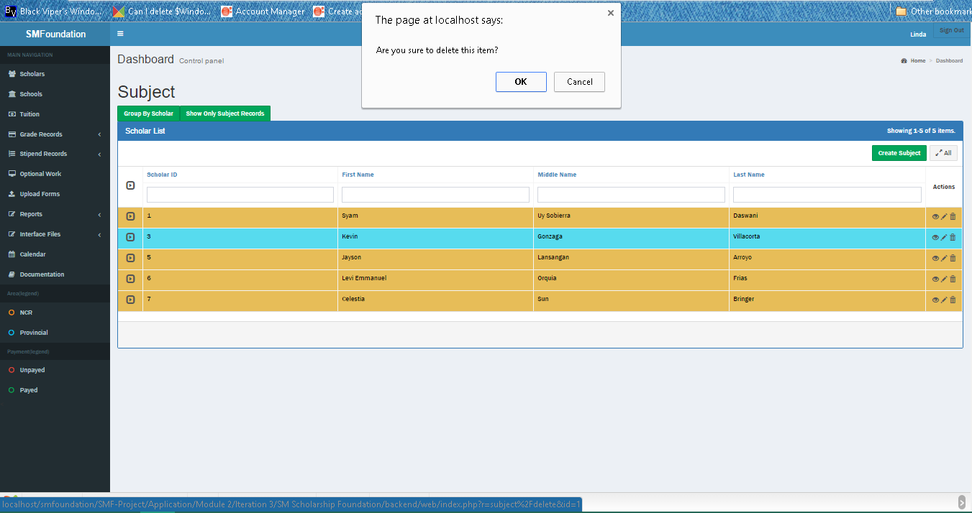Subject (Group by Scholar)
9. Go to Grade Records > Subject Records
10. Hover to the arrow button on the left that displays ‘Expand’
11. In the Actions > Choose the trash bin image
12. A pop-up confirmation will appear. If certain, choose yes; otherwise, cancel
    * + 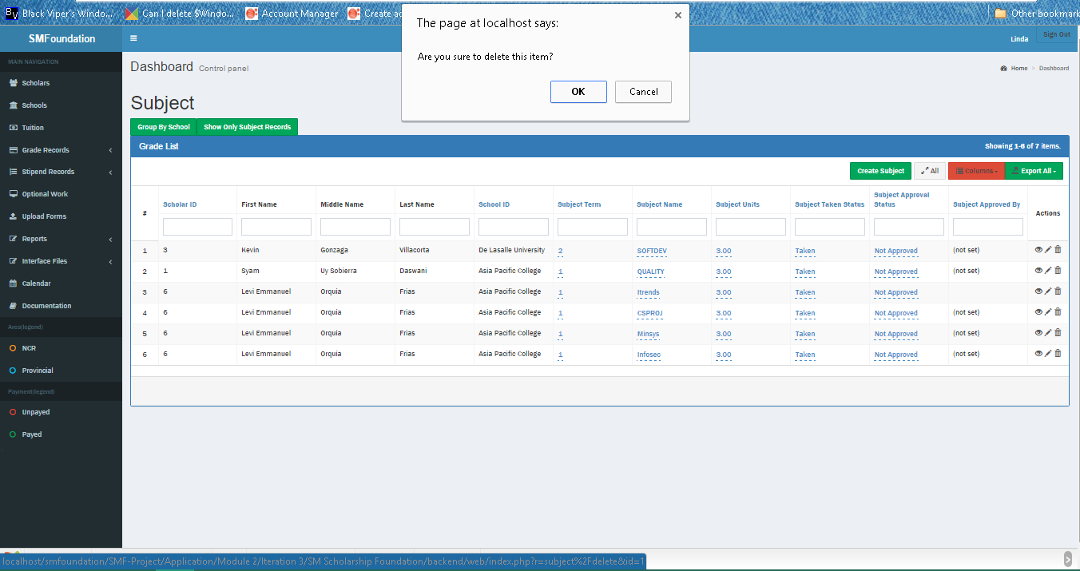Subject (Subjects only)
13. Switch to Show Only Subject Records Tab
14. In the Actions, Click the trash bin image
15. A pop-up confirmation will appear.
16. Choose
    * + Tuition (Group by School)

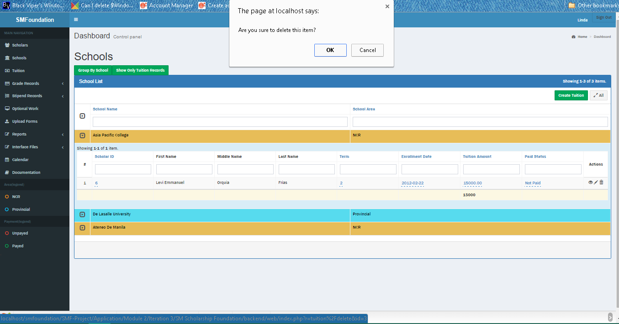

1. Go to Tuition
2. Hover to the arrow button on the left that displays ‘Expand’
3. In the Actions > Choose the trash bin image
4. A pop-up confirmation will appear. If certain, choose yes; otherwise, cancel
   * + Tuition (Tuition only)

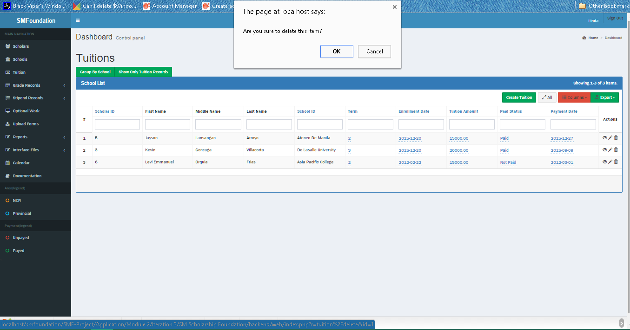

1. Switch to Show Only Tuition Records Tab
2. In the Actions, Click the trash bin image
3. A pop-up confirmation will appear.
4. Choose
   * + 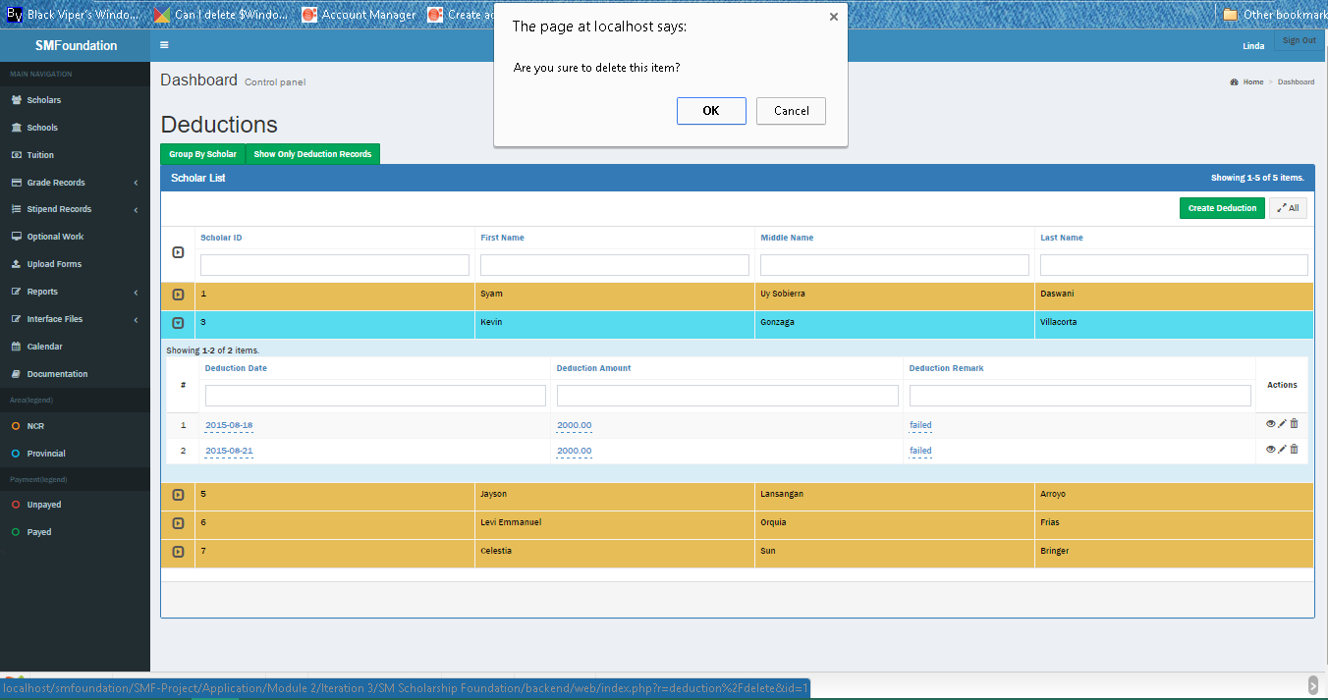Deduction (Group by Scholar)
5. Go to Stipend Records > Deductions
6. Hover to the arrow button on the left that displays ‘Expand’
7. In the Actions > Choose the trash bin image
8. A pop-up confirmation will appear. If certain, choose yes; otherwise, cancel
   * + Deduction (Deductions only)

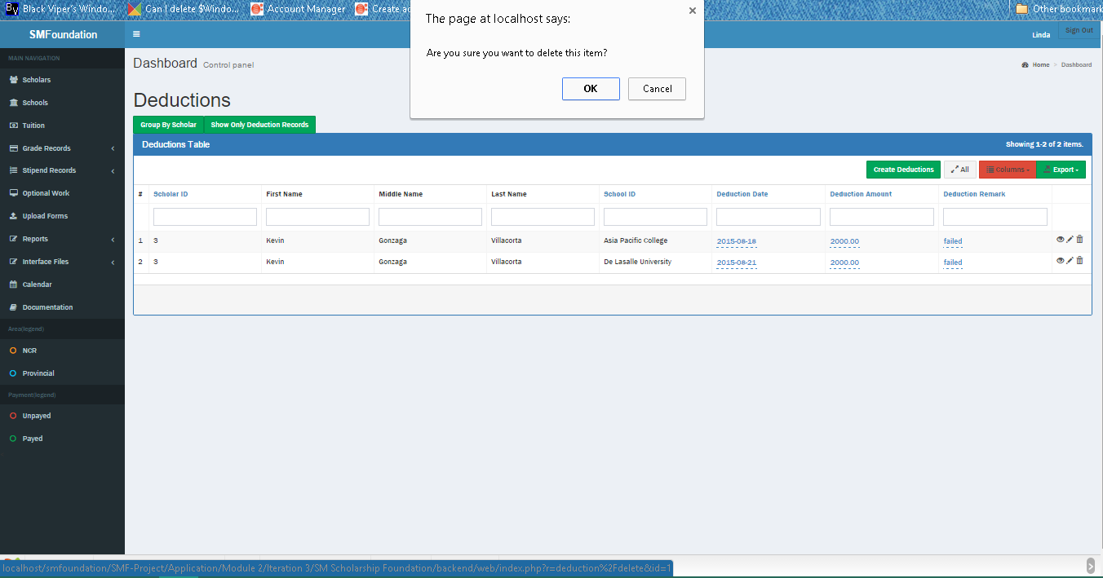

1. Switch to Show Only Deduction Records Tab
2. In the Actions, Click the trash bin image
3. A pop-up confirmation will appear.
4. Choose
   * + Optional work (Group by Scholar)

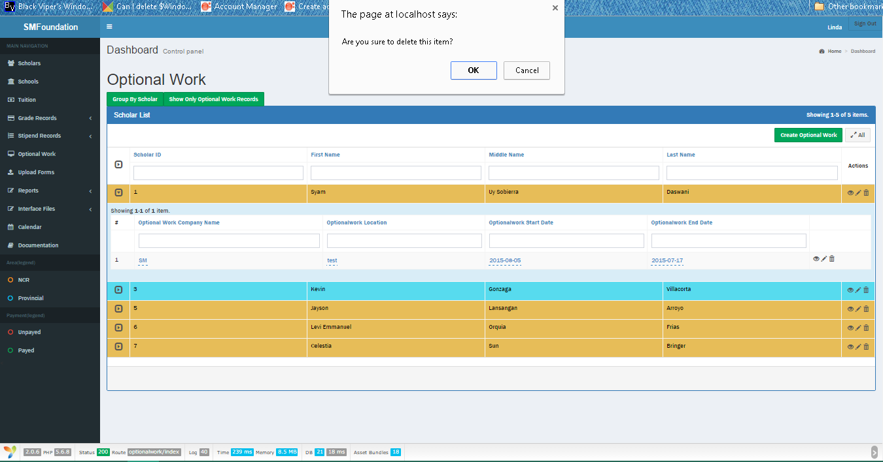

1. Go to Optional Work
2. Hover to the arrow button on the left that displays ‘Expand’
3. In the Actions > Choose the trash bin image
4. A pop-up confirmation will appear. If certain, choose yes; otherwise, cancel
   * + 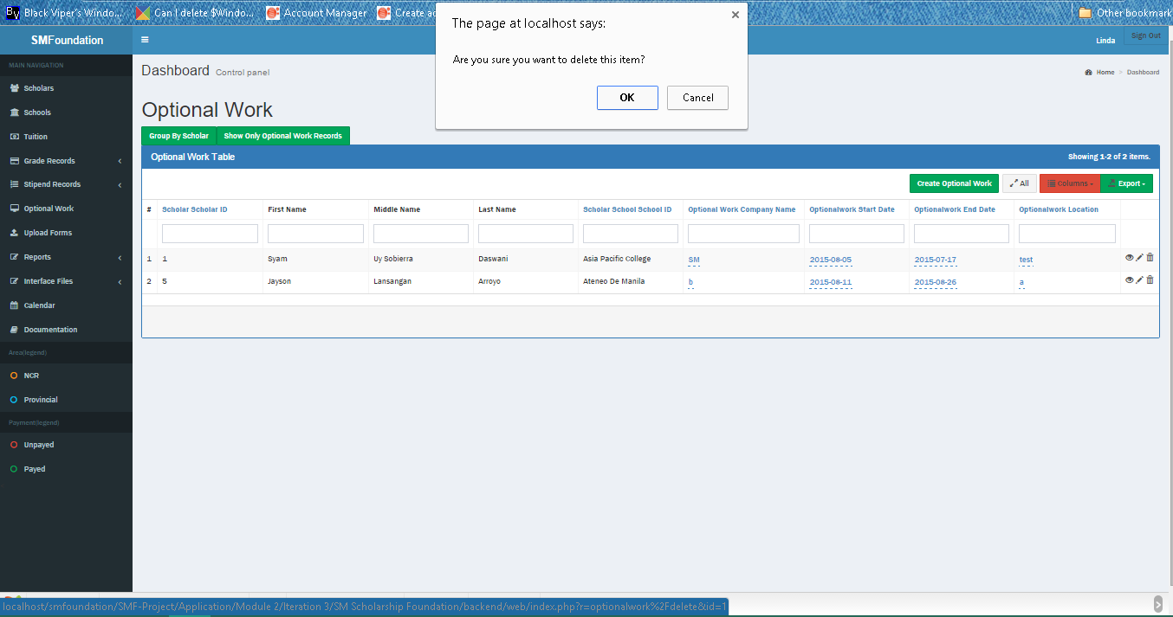Optional work (Works only)
5. Switch to Show Only Optional Work Records Tab
6. In the Actions, Click the trash bin image
7. A pop-up confirmation will appear.
8. Choose
   * Generate report
     + 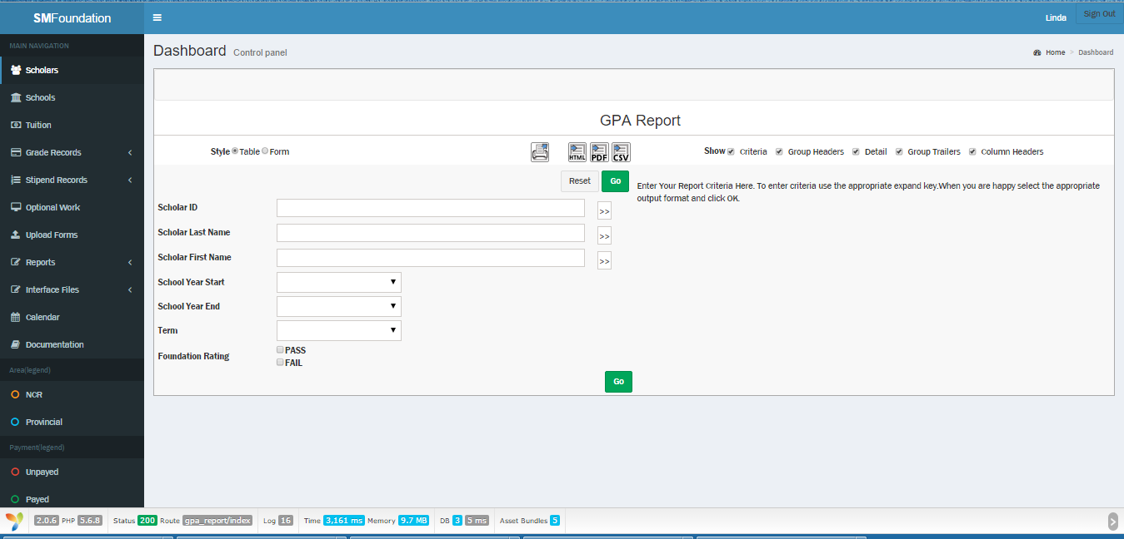GPA
9. Go to Reports > GPA Report
10. Fill out the criteria fields based on what you want to see
11. Go
    * + 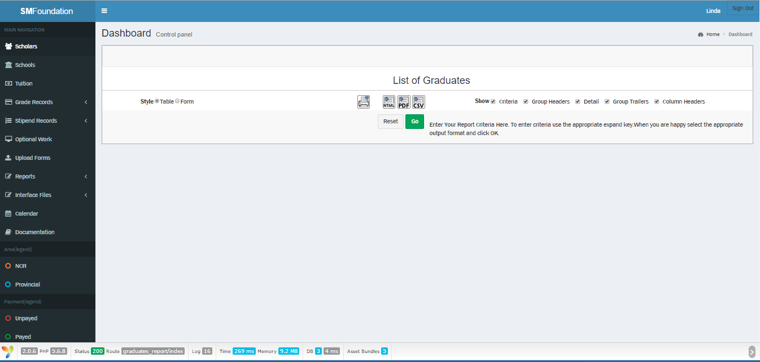Graduates
12. Go to Reports > Graduates Report
13. Fill out the criteria fields based on what you want to see
14. Go
    * + 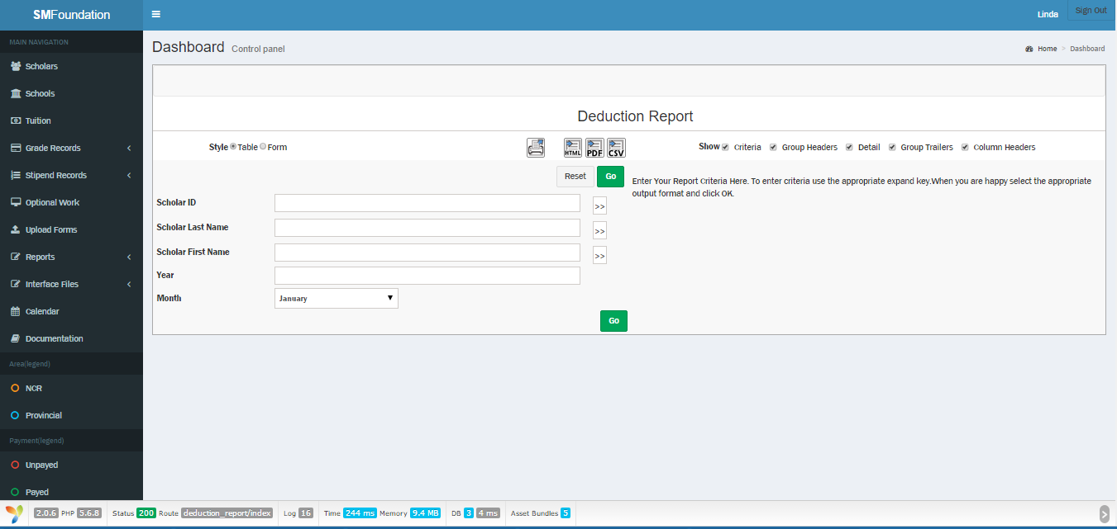Deduction
15. Go to Reports > Deduction Report
16. Fill out the criteria fields based on what you want to see
17. Go
    * + 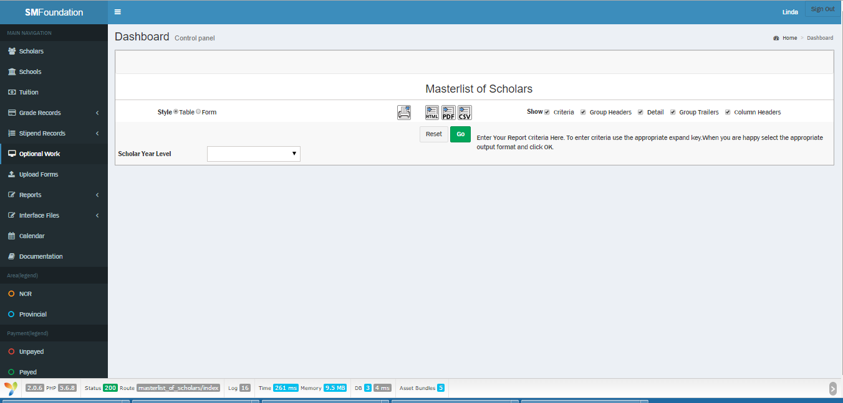Master list of Scholars
18. Go to Reports > Masterlist of Scholars
19. Fill out the criteria fields based on what you want to see
20. Go
    * + 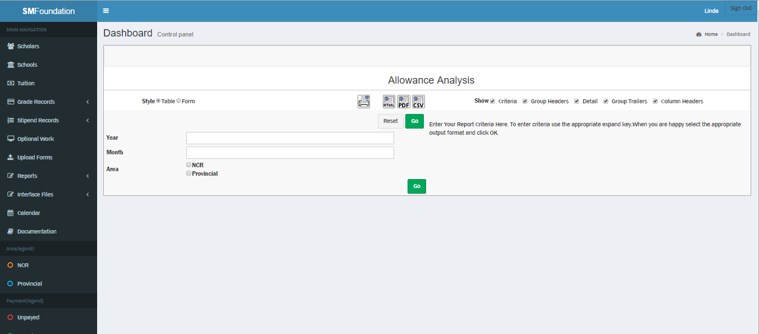Allowance
21. Go to Reports > Allowance Analysis
22. Fill out the criteria fields based on what you want to see
23. Go
    * + Tuition Fee

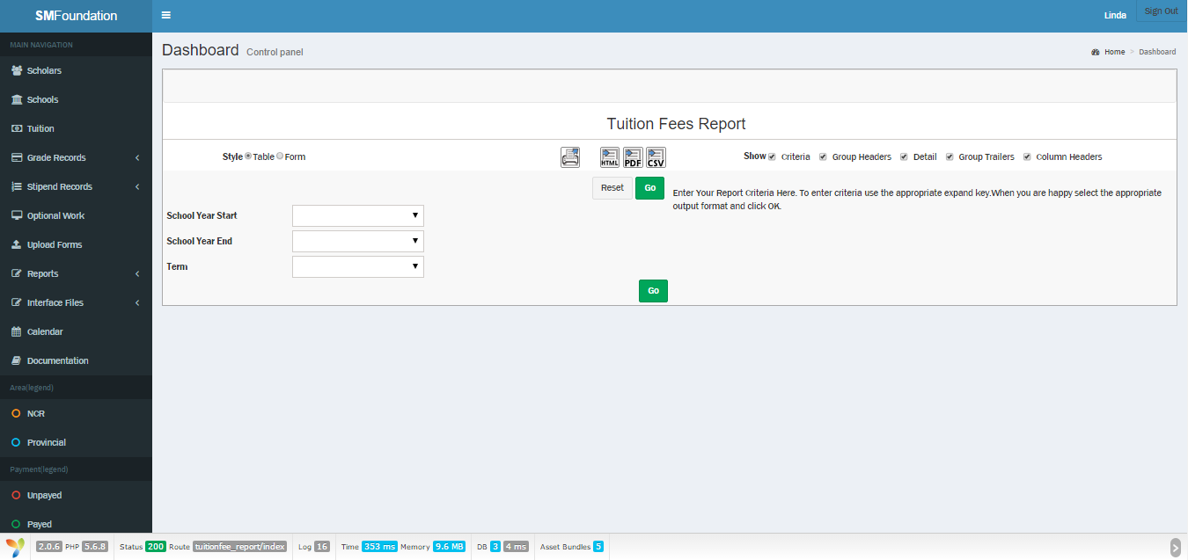

1. Go to Reports > Tuition Fees Report
2. Fill out the criteria fields based on what you want to see
3. Go
   * EXPORT

* 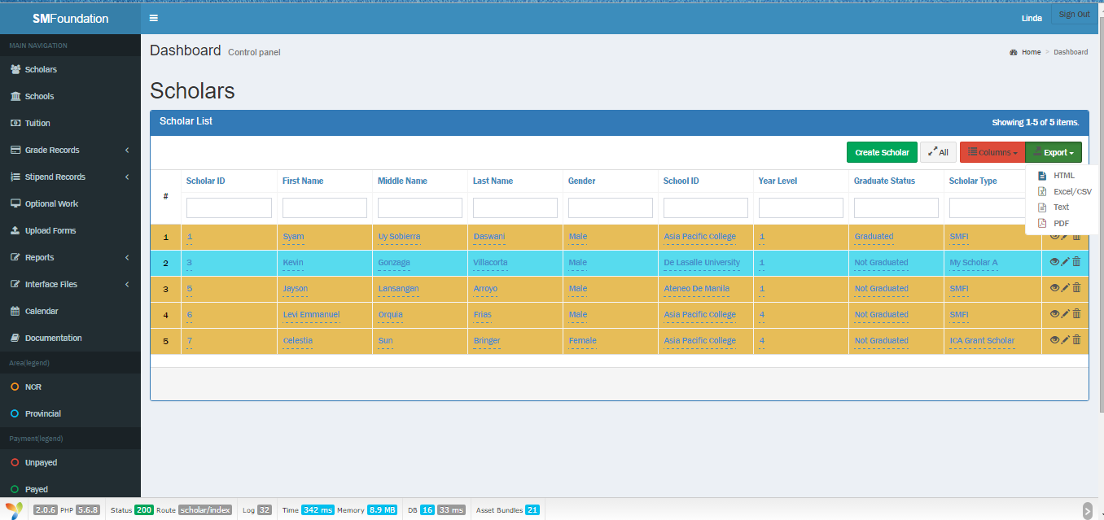Scholar
  + - 1. Go to Scholars
      2. In the upper right corner, click Export
      3. Choose your preferred file type
      4. A pop-up confirmation will appear. If certain, press yes; otherwise, cancel
* 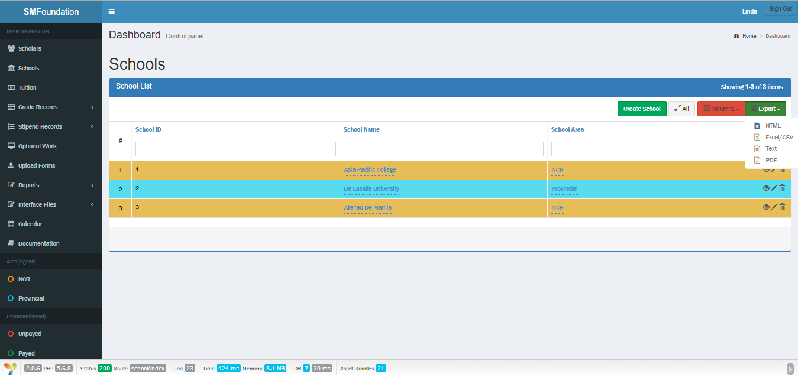Schools

1. Go to Schools
2. In the upper right corner, click Export
3. Choose your preferred file type
4. A pop-up confirmation will appear. If certain, press yes; otherwise, cancel

* 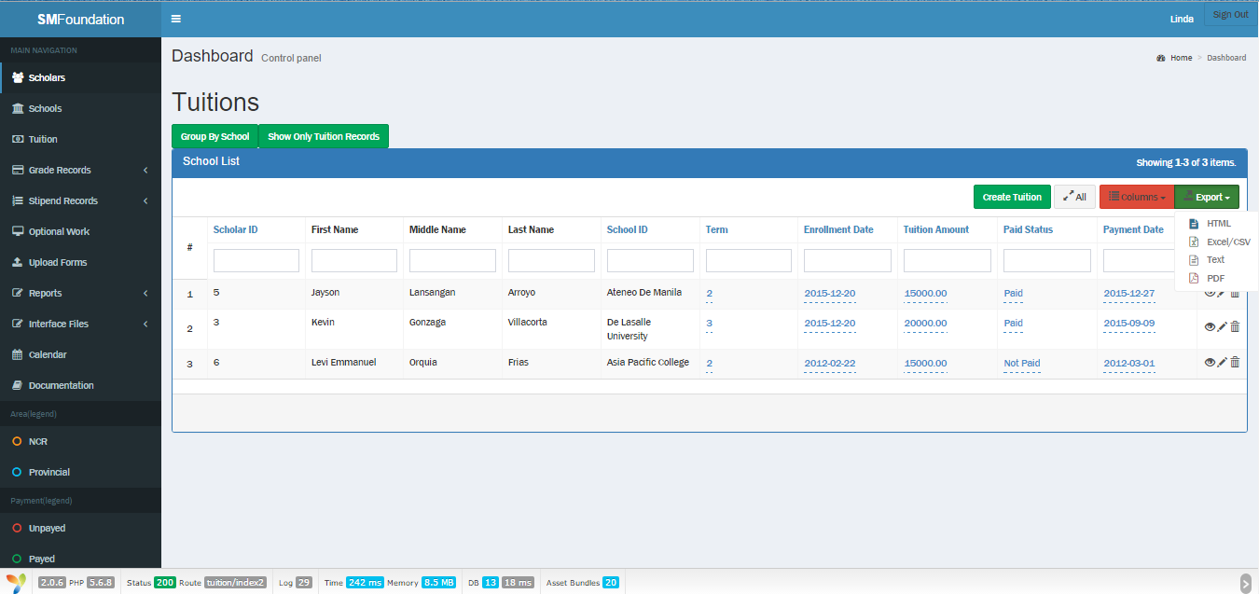Tuition

1. Go to Tuition
2. Switch to Show Only Tuition Records
3. In the upper right corner, click Export
4. Choose you preferred file type
5. A pop-up confirmation will appear. If certain, press yes; otherwise, cancel

* 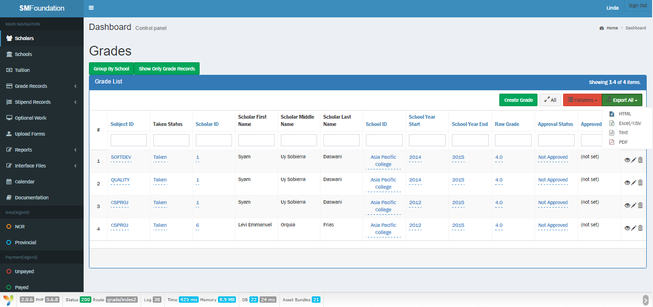Grades

1. Go to Grade Records > Grades
2. Switch to Show Only Grade Records Tab
3. In the upper right corner, click Export All
4. Choose your preferred file type
5. A pop-up confirmation will appear. If certain, press yes; otherwise, cancel

* 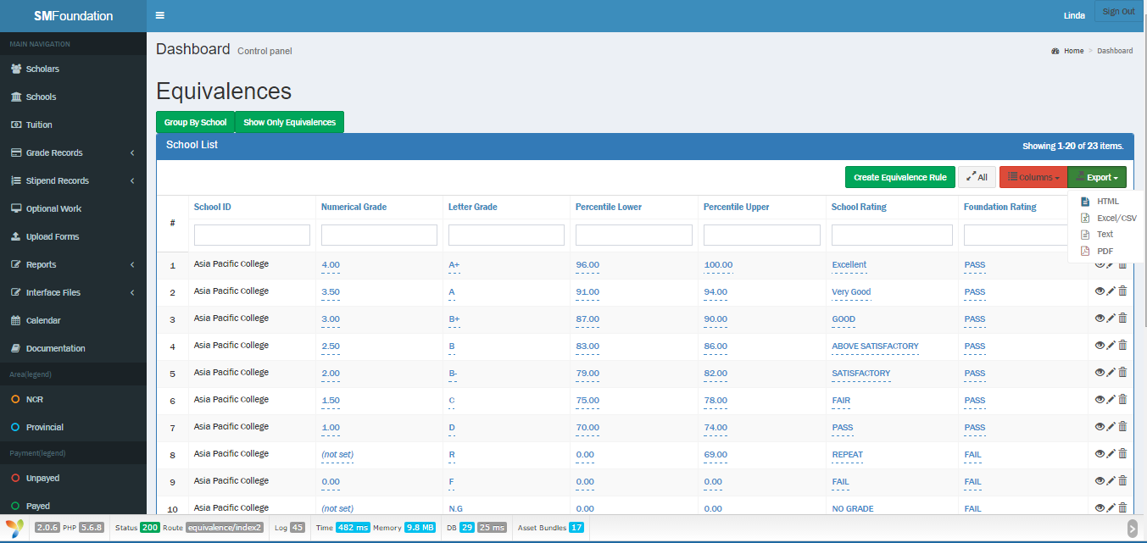Grade equivalence

1. Go to Grade Records > Grading Equivalence
2. Switch to Show Only Equivalences Tab
3. In the upper right corner, click Export
4. Choose your preferred file type
5. A pop-up confirmation will appear. If certain, press yes; otherwise, cancel

* 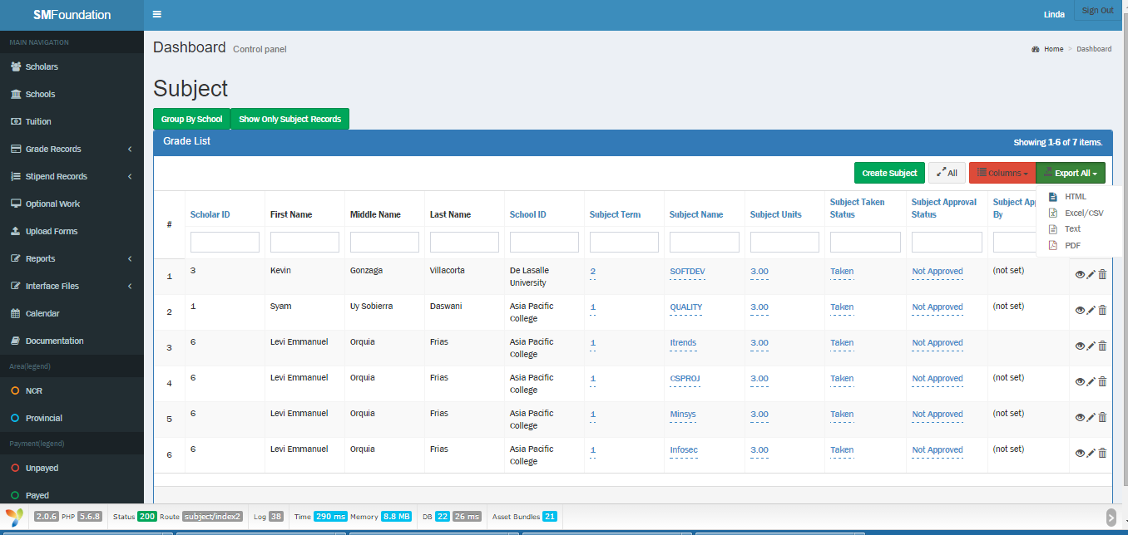Subject

1. Go to Grade Records > Subject Records
2. Switch to Show Only Subject Records Tab
3. In the upper right corner, click Export All
4. Choose your preferred file type
5. A pop-up confirmation will appear. If certain, press yes; otherwise, cancel

* 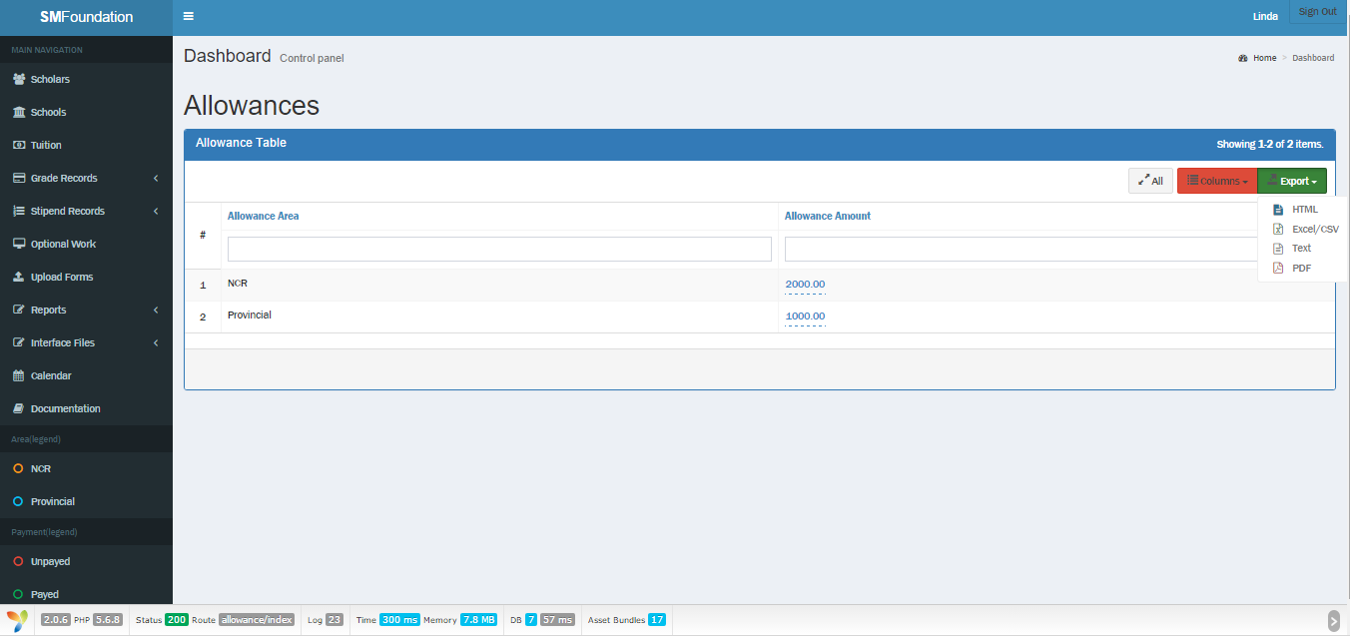Allowance

1. Go to Stipend Records > Allowance Reference Table
2. In the upper right corner, click Export
3. Choose your preferred file type
4. A pop-up confirmation will appear. If certain, press yes; otherwise, cancel

* 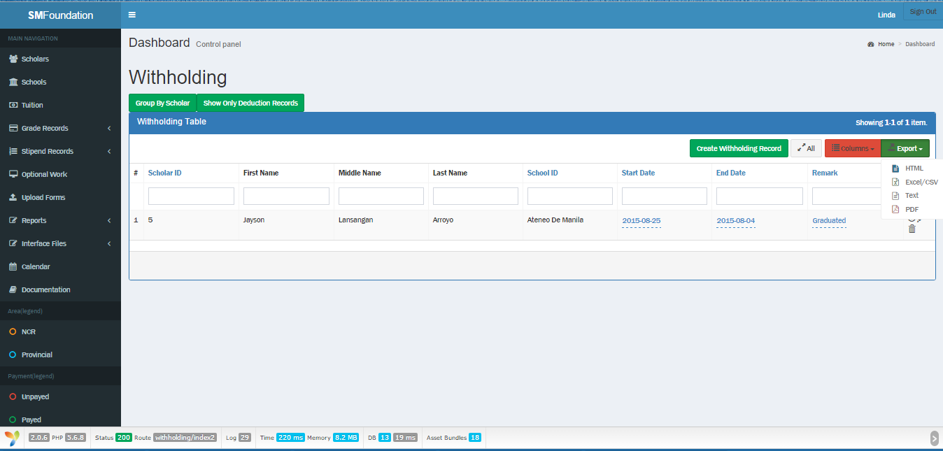Withholding

1. Go to Stipend Records > Withholding
2. Switch to Show Only Withholding Records Tab
3. In the upper right corner, click Export
4. Choose your preferred file type
5. A pop-up confirmation will appear. If certain, press yes; otherwise, cancel

* 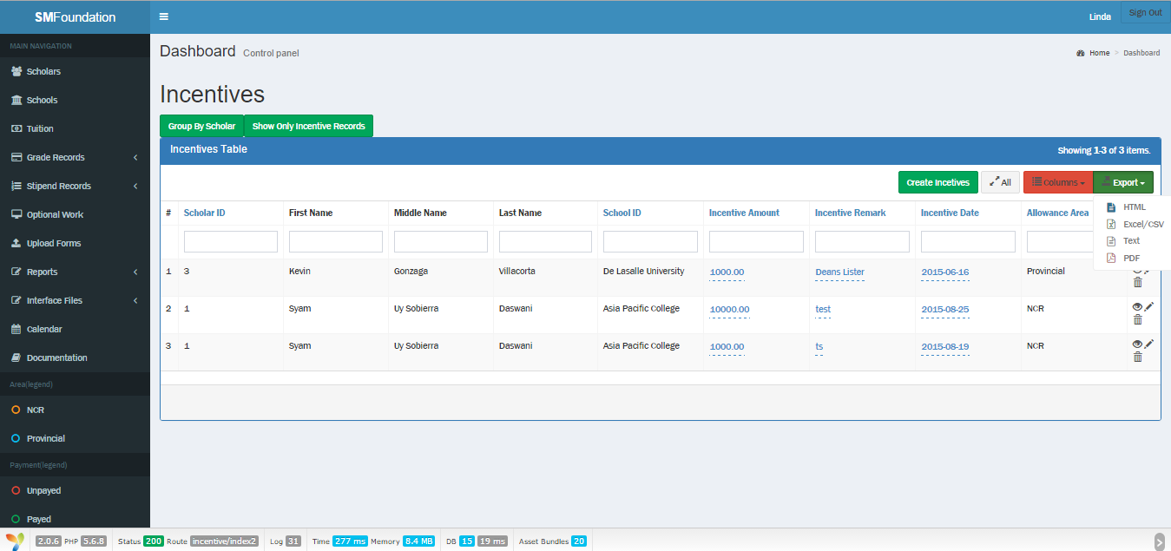Incentives

1. Go to Stipend Records > Incentives
2. Switch to Show Only Incentive Records Tab
3. In the upper right corner, click Export
4. Choose your preferred file type
5. A pop-up confirmation will appear. If certain, press yes; otherwise, cancel

* 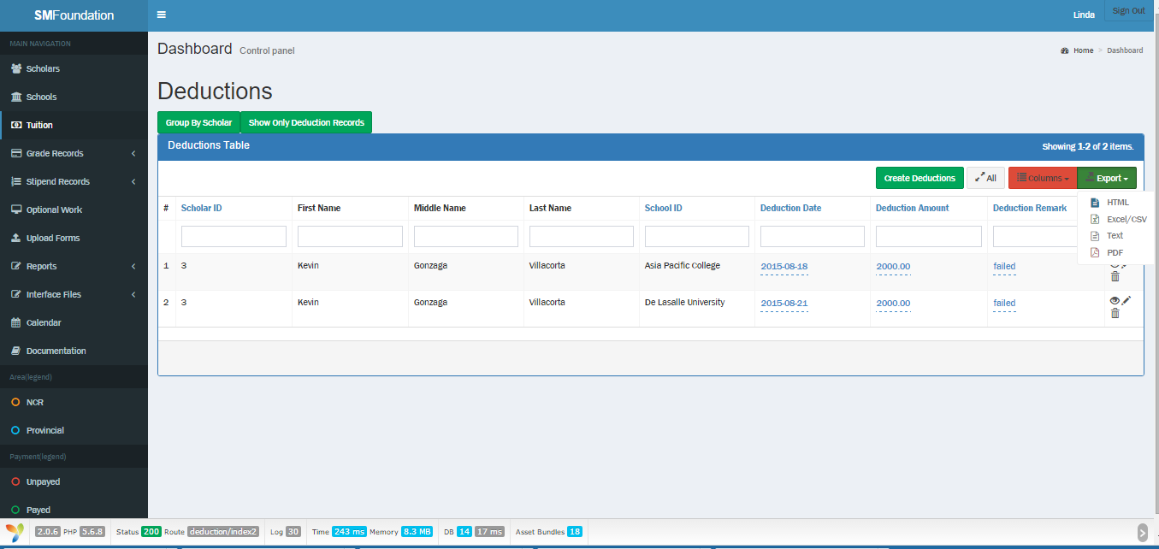Deductions

1. Go to Stipend Records > Deductions
2. Switch to Show Only Deduction Records Tab
3. In the upper right corner, click Export
4. Choose your preferred file type
5. A pop-up confirmation will appear. If certain, press yes; otherwise, cancel

* 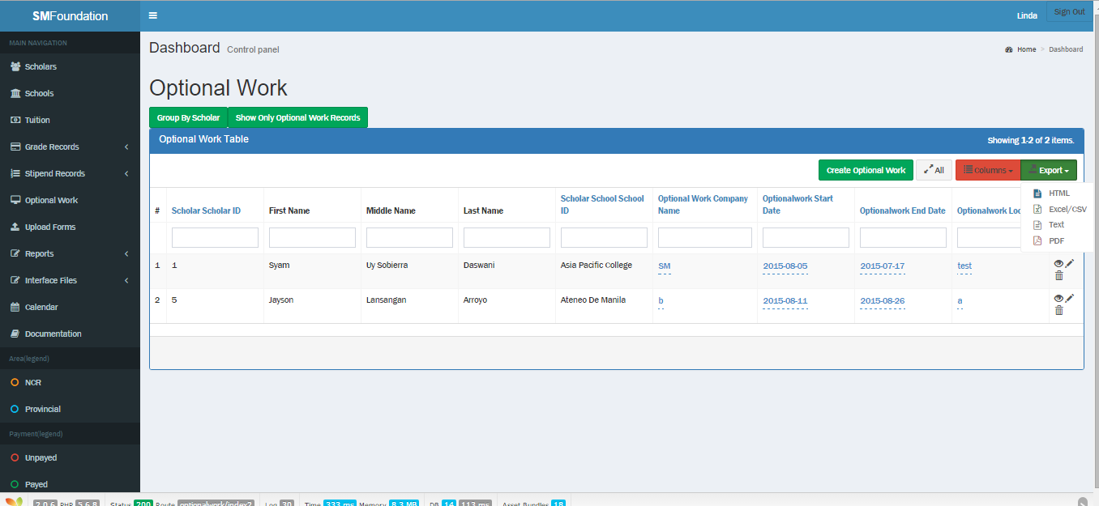Optional work

1. Go to Optional Work
2. Switch to Show Only Optional Work Records Tab
3. In the upper right corner, click Export
4. Choose your preferred file type
5. A pop-up confirmation will appear. If certain, press yes; otherwise, cancel